**Introduction to Engineering Design with Professional Development 1**

**Final Report for**

**Vibrating Alarm Clock**

**Team: Nocturnal Knock Turtle**

**Section 08**

**Instructors: Casey Jakubowski, Dr. Paul Moon**

**Version 1.0**

**May 1, 2017**

**Prepared by**

|  |  |
| --- | --- |
| **Andrew Travis** | **(SO/AERO)** |
| **Jacqueline Floyd** | **(SO/MECH)** |
| **Ria Shroff** | **(SO/BME.PDI)** |
| **Samuel Pollinger** | **(SO/AERO)** |
| **Maeve Tucker** | **(SO/CIVL)** |
| **Shiyan Yang** | **(SO/MECH)** |

**Executive Summary**

The vibrating alarm clock is an innovative design that utilizes the quietness of the vibration to wake people while not being disruptive to the user’s roommate. This product has a series of vibrating motors buried in a heat-and-electric proof padding that goes right under the user’s back. This pad will send out a wave of vibration to wake the user up, while any unnecessary noise will be absorbed by the padding. The product also uses two buzzers as failsafe. The buzzers will sound if the user does not snooze the alarm clock after 30 seconds of vibration.

We started this project with a comprehensive survey to investigate what people think about the regular alarm clocks in the market, what features they would like to be added on a new design, and are they experiencing being awakened by another person’s alarm clock. These questions laid the foundation for our project and gave us the specification we needed for our prototype. After benchmarking with similar existing product and carefully selecting a concept, we separated the work into six subsystems that each team member could work on mainly independently, maximizing our efficiency as a team. After we integrated the subsystems, we tested the prototype with the performance specification we set for ourselves.

The prototype met all specifications and was fully capable of serving its purpose. However, there were still improvements that could be made to make the product more competitive in the market. If this product were to be put into production, it should reduce tension between many roommates that have already been troubled with conflicting schedules.

**Table of Contents**

**Introduction** **5**

**Project Objectives & Scope** **6**

Mission Statement 6

Customer Requirements 6

Technical Specifications 11

**Assessment of Relevant Existing Technologies** **12**

**Professional and Societal Considerations** **16**

**System Concept Development and Selection** **17**

**Subsystem Analysis and Design** **19**

Subsystem 1: Clock Module 19

Subsystem 2: Vibration 20

Subsystem 3: Speakers 22

Subsystem 4: Safety 25

Subsystem 5: Power supply 26

Subsystem 6: Casing 30

**Results and Discussion** **34**

Results 34

Significant Technical Accomplishments 35

**Conclusions** **36**

**References** **38**

**Appendix A: Selection of Team Project** **40**

**Appendix B: Customer Requirements and Technical Specifications** **43**

**Appendix C: Gantt Chart** **56**

**Appendix D: Expense Report** **57**

**Appendix E: Final Code** **58**

**Appendix F: Team Members and Their Contributions** **61**

Team Member 1: Andrew Travis 61

Team Member 2: Jacqueline Floyd 61

Team Member 3: Maeve Tucker 61

Team Member 4: Samuel Pollinger 62

Team Member 5: Shiyan Yang 62

Team Member 6: Ria Shroff 63

**Appendix G: Statement of Work** **64**

**Appendix H: Professional Development - Lessons Learned** **65**

**Appendix I: User Manual** **67**

# Introduction

Alarm clocks have a seemingly insignificant impact on society, so people seldom consider the negative impact it can have on human relationships. Especially when having a schedule different from a roommate, a college student might find themselves in the situation where both of their alarm clocks are keeping them away from a long, comfortable sleep. Thus, the design team of Nocturnal Knock Turtle aims to create an alarm clock that, while maintaining its original purpose, keeps the peace between roommates.

The foundation of our project is based on the customer’s need to be effectively awakened, while keeping the disturbance to others caused during the process to a minimum. The product must be able to produce a stimulus that is only receivable to the customer itself. Also, since this product will be used in the customer’s daily life, the prototype should be durable, affordable, and easy to use. The prototype should have a safety mechanism to reduce the probability of the customer sleeping over the alarm, too.

The successful creation of this prototype could bring ease and comfort to college campus that are already filled with stress, for it prevents unnecessary tension between roommates during each other’s wake-up period.

The following document will expand on the objectives and scope of the project and consider the similar existing products in the markets. Then, the document will explain the professional and societal selection consideration when we were developing the idea and the system concept development and selection. In addition, each subsystem of the prototype will be introduced and discussed. Last and more importantly, the documentation will demonstrate the testing results and what this project has accomplished.

# Project Objectives & Scope

* Create one fully functioning alarm clock prototype
* Have each subsystem perform its required specification
* Successfully work together as a group through any obstacles
* Complete the project on time
* Get an A on the project between the demo, presentations, and the memos

## Mission Statement

Figure 1: Mission Statement

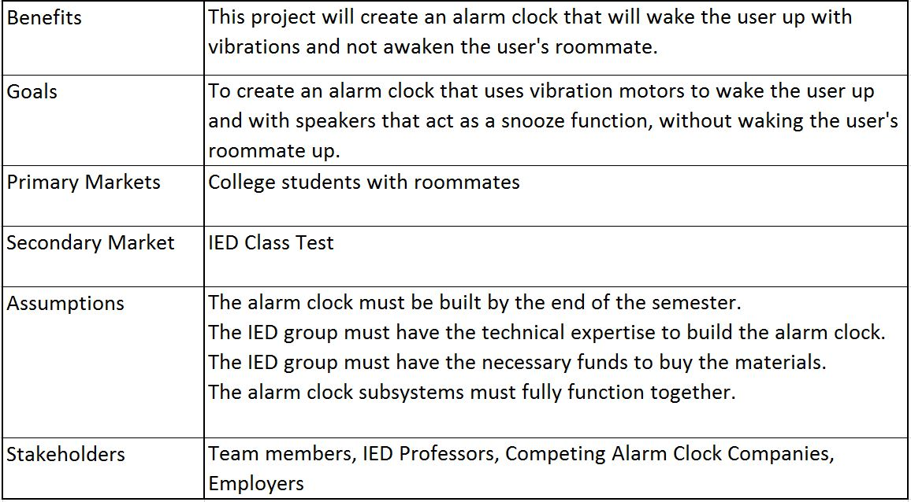

## Customer Requirements

The target customers for our alarm clock are primarily college students. As college students ourselves, we have access to a large enough sample population to adequately collect customer needs and test the prototype*.* College students also serve as a model audience as many share rooms and thus have experienced the problem of being awakened by others’ alarm clocks. With this target audience in mind, we created and shared a survey about sleep and waking habits. The poll was circulated through college (primarily RPI) students. We used the survey responses to create a model of our typical consumer.

We found that of the applicable responses, 44.5% of people reported commonly being wakened by someone else’s alarm, showing that this target audience would benefit from our product. Figure 2: Nightly Activity shows the responses of levels of movement during the night. Most reported moving a moderate amount (defined on the survey as rolling over a few times) during the night. This wastaken into consideration when developing ideas for placement of the alarm system. Due to the small percentages of participants who reported excessive movement during the night, we chose to exclude this group from our audience and instead focus on the more average responses. Similarly, we chose to exclude very light or very heavy sleepers. Figure 3: How Easily are You Awakened shows the majority of respondents were between 3 and 8 on a scale from 1 to 10 with 1 being extremely easily awoken.

Figure 2: Nightly Activity

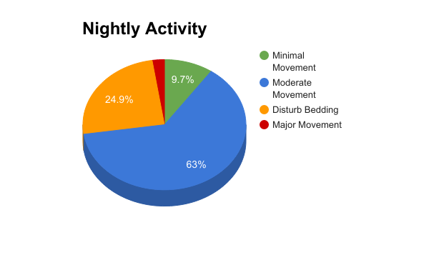

Figure 3: How Easily are You Awakened?

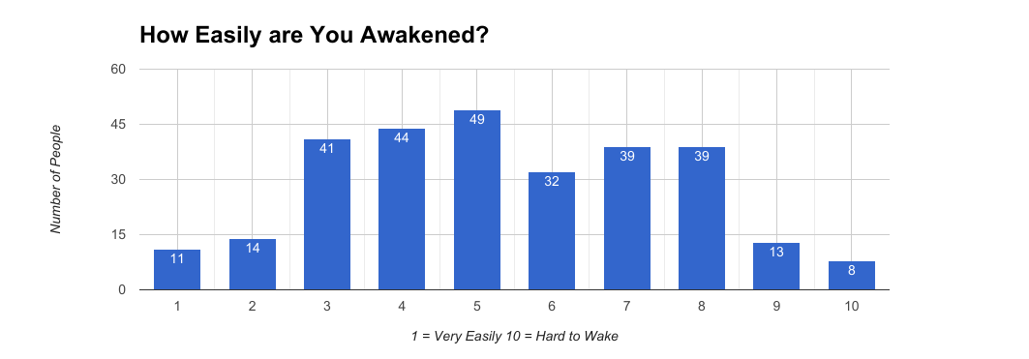

We also found that most of the respondents use a fitted sheet on their bed. The survey, as well as interviewing students, allowed us to create a complete list of customer requirements for a general alarm clock. A summary of customer requirements collected are shown in Figure 4: Table of Primary and Secondary Customer Requirements. Within the table, requirements are categorized into primary groups with specific needs listed beneath each. The number of asterisks next to each need denotes the importance, with *** being most important. Needs with an X next to them are ones we chose to exclude from our project. Decisions to exclude needs were based upon the concept we developed. This table also includes latent needs gathered from interviews and product reviews that were not overtly expressed by the customers initially. For example, comfort of the alarm clock system was not usually a consideration when thinking of a traditional alarm clock. Until a prototype was created and customers evaluated it, there was no information on this customer requirement. The customer needs were additionally simplified and prioritized in Figure 5: Prioritized Requirements.

Figure 4: Table of Primary (bolded) and Secondary Customer Requirements.

|  |  |  |  |
| --- | --- | --- | --- |
| **\***  **\*\*\***  **\*\***  **\*\***  **\***  **\*\*\***  **\*\***  **\***  **\*\*\***  **\*\*\***  **\*\*\***  **X**  **\***  **\*\***  **\*\*\***  **\*\*\***  **\*\*\***  **\*\*\***  **\*\*\***  **\*\*\***  **\*\*\***  **\*\*\***  **\*\***  **\*\***  **\***  **X**  **\*\***  **\*\***  **\*\***  **\***  **\*\*\***  **\*\***  X  **  **  *** | **The alarm clock is easy to use.**  The alarm clock has minimal number of controls.  The alarm clock has clearly labeled parts.  The alarm clock screen is easy to read.  The alarm clock screen displays the selected function.  The alarm clock is low maintenance.  The alarm clock can be installed quickly.  The alarm clock can be relocated.  The alarm clock requires no assembly.  The alarm clock is cost efficient.  The alarm clock is easy to reset.  The alarm clock can work on a variety of beds.  The alarm clock can be used without a nightstand.  **The alarm clock is safe.**  The alarm clock casing is smooth.  The alarm clock casing has no sharp parts.  The alarm clock casing contains necessary electrical components.  The alarm clock casing does not become hot.  The alarm clock does not shock the user.  The alarm clock electronics are properly insulated.  The alarm clock does not cause a fire.  **The alarm clock wakes user at given time.**  The alarm clock reliably tells time.  The alarm clock alarm time can be set by user.  The alarm clock initiates wake-up sequence at appropriate time.  The alarm clock has a secondary way to ensure the user wakes.  The alarm clock is hard to ignore.  The alarm clock placement is secure.  The alarm clock has backup battery power.  The alarm clock is still effective if the user changes positions.  The alarm clock is unhindered if the user places pillow/arm over head.  **The alarm clock’s effects are isolated to the user.**  The alarm clock only alerts one user.  The alarm clock does affect anything outside of the room.  The alarm clock is not heard by others sleeping in the vicinity.  The alarm clock is not distracting to others.  The alarm clock can wake only the user even if they are sharing a bed.  The alarm clock does not take up a large amount of space.  The alarm clock does not obstruct the bed.  The alarm clock does not interfere with the other bed in a set of bunkbeds. | **\*\*\***  **\*\*\***  **X**  **\*\***  **\*\***  **\***  **\***  **\*\***  **X**  **\*\***  **\*\*\***  **\***  **\*\***  **\***  **\*\*\***  **X**  **\*\***  **\***  **X**  **\*\*\***  **\*\***  **\*\***  **X**  **\*\*\***  **\*\*\***  **X**  **\***  **\*\***  **\***  **\***  **\*\*\***  **\*\*\***  **\*\***    **\*\***  **\*** | **The alarm clock is durable.**  The alarm clock case can withstand use of controls without deforming.  The alarm clock case does not bend under small (10 lb) force.  The alarm clock casing does not break if knocked over.  The alarm clock wire connections are secure.  The alarm clock accessories are protected for normal use.  The alarm clock accessories can withstand necessary forces.  The alarm clock has a long life span.  The alarm clock can be used regularly.  The alarm clock is weather resistant.  **The alarm clock allows normal sleep until set time.**  The alarm clock accessories cause minimal discomfort.  The alarm clock only alarms at given time.  The alarm clock screen is not a bright light source.  The alarm clock allows movement during sleep.  The alarm clock does not requires skin contact.  The alarm clock does not prevent certain sleeping positions.  The alarm clock provides white noise to fall asleep to.  The alarm clock functions even if blankets, pillows are moved.  **The alarm clock is pleasant to wake to.**  The alarm clock does not wake user violently.  The alarm clock uses light to wake the user.  The alarm clock uses vibrations to wake the user.  The alarm clock sound is not jarring.  The alarm clock sound is muted.  The alarm clock tracks sleep cycles.  The alarm clock does not cause panic.  The alarm clock is distinguishable from other stimuli.  The alarm clock gradually wakes the user.  **The alarm clock is aesthetically pleasing.**  The alarm clock looks finished.  The alarm clock does not have visible flaws.  The alarm clock can be placed in different settings.  The alarm clock has a minimalistic design.  The alarm clock’s wires are contained/wrapped.  **The alarm clock can wake light to heavy sleepers.**  The alarm clock placement can be decided by user.  The alarm clock and accessories will not be dislodged by moderate nightly movement.  The alarm clock has a secondary alarm if primary alarm is insufficient.  The alarm clock alarm volume can be customized by user. |

Figure 5: Prioritized Requirements

|  |  |
| --- | --- |
| **Need** | **Importance (5 being the most)** |
| Safety | 5 |
| Comfort | 4 |
| Cost | 2 |
| Wakes Only User | 4 |
| Reliable | 5 |

Collecting general alarm clock requirements from our target audience allowed us to consider what specific system we wanted to create. Many alternate concepts were generated, but we decided to use a vibrating system. More in depth explanation of concept selection can be found in section 5. We interviewed individual students about their current alarm clock and their evaluations of it. A sample customer data template and multiple detailed customer requirements can be found in Appendix B: Customer Requirements and Technical Specifications. The need statements gathered supported our choice of proceeding with an alarm clock with vibrating pad.

## Technical Specifications

Based on the survey we conducted, we could conclude that there are four basic requirements for our target customers, which are probably the common requirement any customers would set for an alarm clock. Those are: affordability, durability, reliability, and user friendly. Also, since the project requires an alarm clock to be non-disturbing to others, we would also want to set a range for noise it would possibly be making. Eventually, we added the aspect of safety. Since people do not typically worry about safety when they purchase an alarm clock, it was not reflected in the initial survey. Figure 6 contains the basic requirements we gathered and their desired technical specifications.

Figure 6: Basic Requirements

|  |  |  |
| --- | --- | --- |
| **Requirement** | **Technical Spec.** | **Target Value** |
| Affordable | prototype cost | < $75 |
| Reliable | Life span | >3 years |
|  | No need to charge | AC power supply |
| Durability | Withstand a certain amount of force | >10lb |
| User-friendly | Large screen | 2’’ X 1’’ |
|  | Cord long enough to reach wall plug | 3-5ft |
|  | Reduced number of buttons | <5 |
| Non-disturbing | Make noise | <65dB |
| Safety | Voltage measured at surface of clock | 0 |
|  | Temperature of clock | +5 °F from room temp. |

# Assessment of Relevant Existing Technologies

While designing our project, we looked at several similar products to ensure ours was unique. When evaluating these products, we compared the features they had with the customer requirements we were aiming to meet. We also read online reviews of these products to see what their customers liked and disliked about them.

One of the first notable products we found was the Sharp Vibrating Pillow Alarm Clock [10], shown in Figure 7. This clock is aimed toward hard of hearing or deaf people, and it is meant to be kept under a pillow and vibrate to wake the user. We initially liked the idea of something in or under the pillow, but after discussing, we thought that it could be uncomfortable or could easily fall off the bed in the night. This alarm clock does not rely on Bluetooth, but keeps its own time and has buttons to set the alarm. We thought that with the product having external buttons and being in the user’s bed, it could be possible to accidentally press a button during the night and alter the alarm settings. It is also battery powered. We looked at online customer reviews to get an idea of what people thought of this product, and many people reported that it did not vibrate strongly at all, and could barely be felt through a pillow.

Figure 7: Sharp Vibrating Pillow Alarm [10]

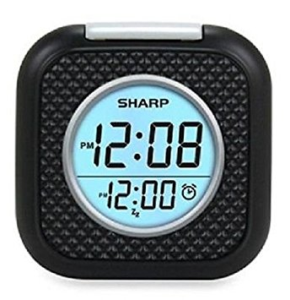

Other products we found were the Amplifyze TCL Pulse Alarm and the Smart Shaker [1],[12]. Both of these products are meant to be kept in the user’s pillowcase or bed, and use Bluetooth to connect to an app to set the alarms. We didn’t like the idea of a product relying on Bluetooth for the alarm to go off in case the connection was lost during the night or the user’s phone battery died. Both of these products are also battery powered, and we decided that batteries can be unreliable based on ethnographic observation in classrooms with other peers’ calculators suddenly dying mid-charge, phones dying midday, etc. The Amplifyze TLC Pulse has a low battery indicating feature, but we wanted to create a product where the user did not have to worry about batteries. These products are both relatively small as well, so we thought it was likely that they would fall off the bed during the night.

To combat the problem of the device falling off the bed, we looked into wearable alarm devices. We came across Shake-n-Wake alarm [11], shown in Figure 8. The user wears the Shake-n-Wake on their wrist and it vibrates to wake them in the morning. There is a screen and buttons on the device to control and set the alarm. While we liked that it does not rely on Bluetooth like some of the other devices we looked at, it seemed that it would be uncomfortable to sleep with a plastic alarm on your wrist, and it could also be possible to accidentally change the settings in your sleep.

Figure 8: Shake-N-Wake Alarm Clock [11]

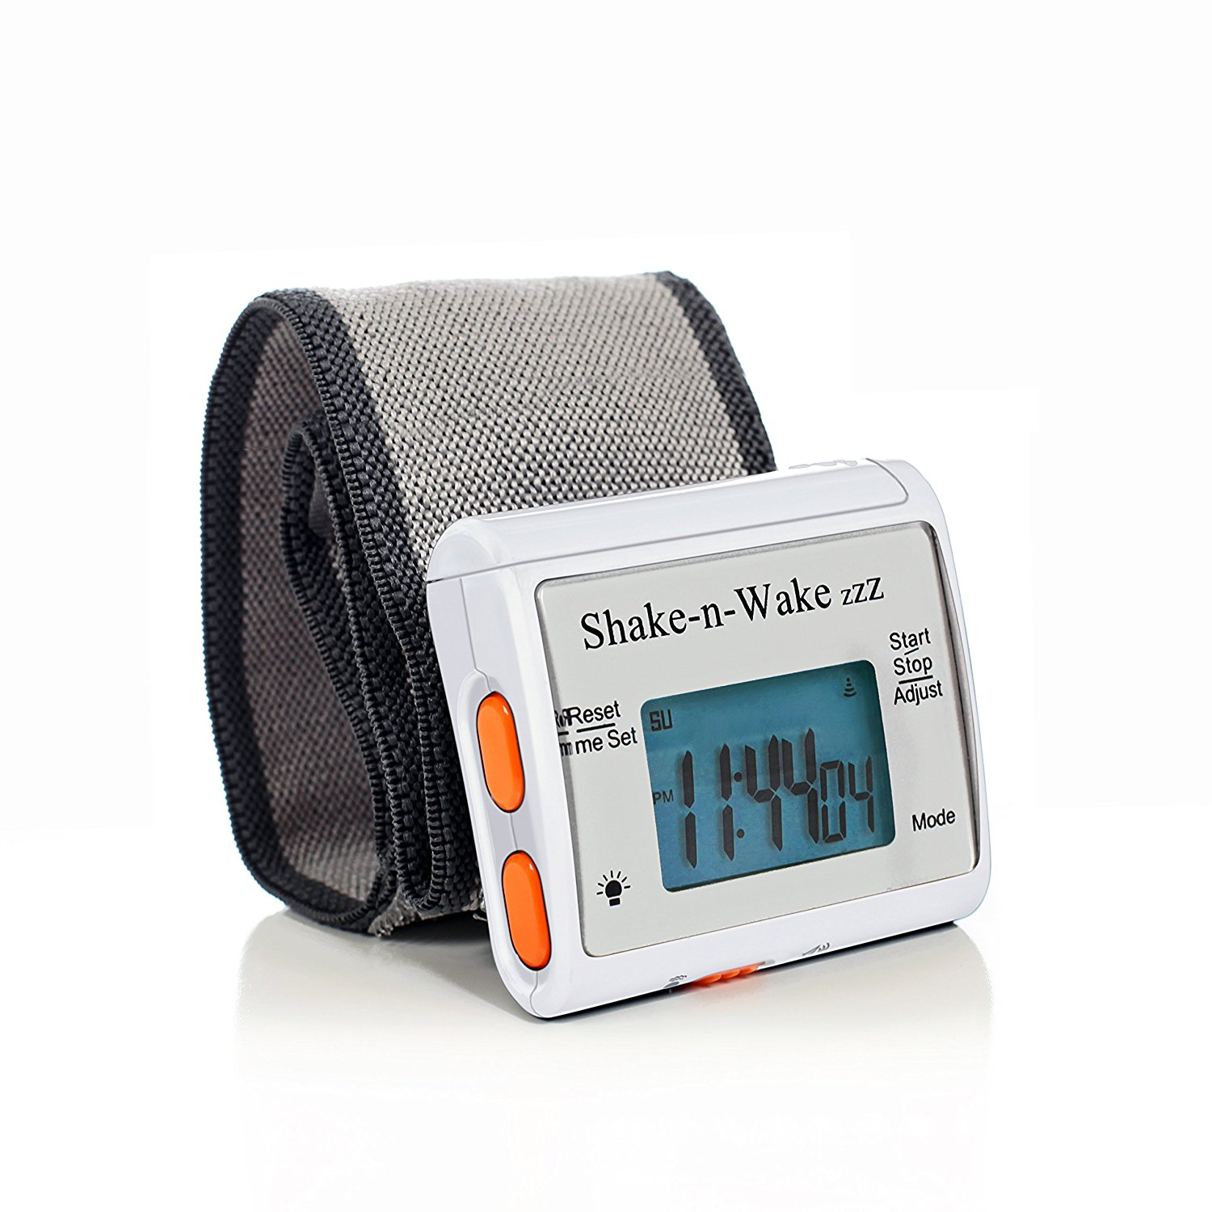

Another product we found was called the Sonic Bomb Alarm clock [13], shown in Figure 9. This product advertises an “extra loud alarm,” with the option of a vibration component as well. The vibration can be turned on or off, but the loud alarm cannot be, so this product did not meet our requirement of not awakening others in the room. We liked that the alarm clock was powered by a wall outlet, and the vibrating component that goes in the bed was connected to the clock by a wire so that the user does not have to worry about batteries or Bluetooth. We read several customer reviews of this product and many stated that the vibrations were weak and could not be felt very well through a pillow, leaving them to rely on the loud tone.

Figure 9: Sonic Bomb Alarm clock [13]

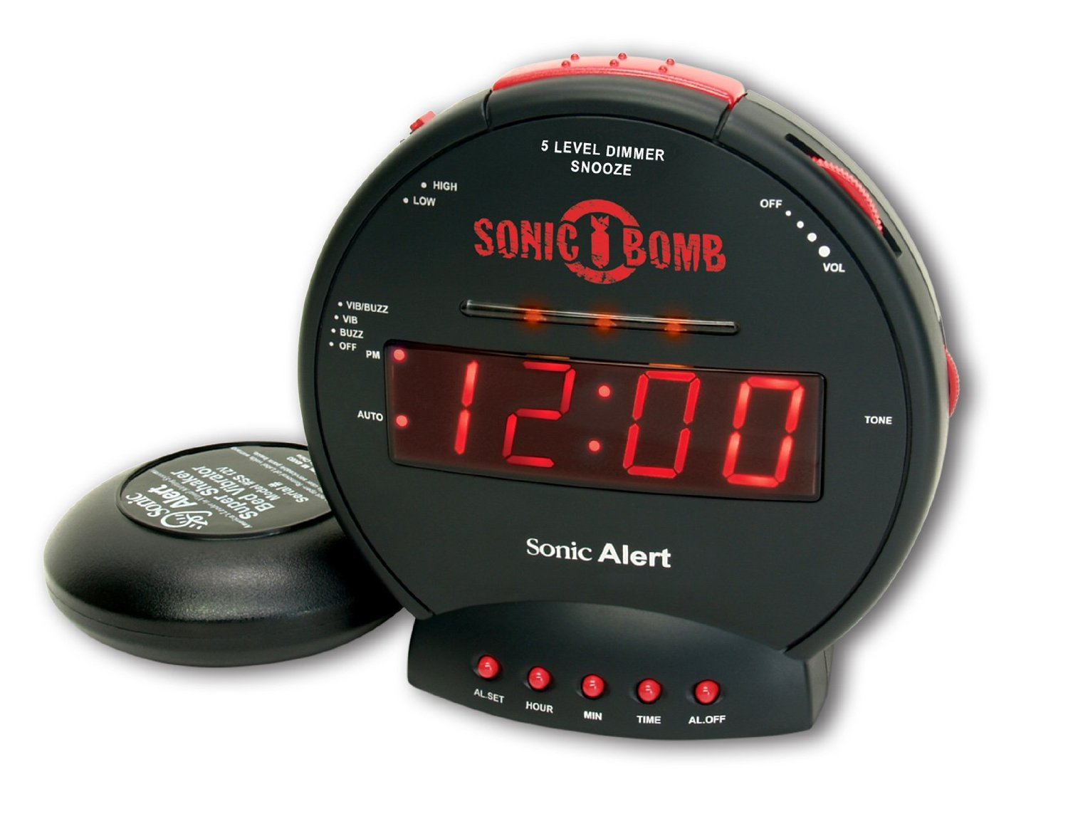

The existing vibrating alarm clocks we reviewed helped us to make sure our product was unique. Researching existing products also helped us decide what features we did and did not want to include and prioritize in our product. The products that we reviewed are summarized in the Competitive Benchmarking table in Figure 10.

Figure 10: Competitive Benchmarking

|  |  |  |
| --- | --- | --- |
| **Competitive Product** | **Title / Description** | **Relation to this project** |
| Sharp Vibrating Pillow  Alarm Clock | Vibrating alarm clock, goes in pillow, battery powered, internal clock | Vibration, does not use Bluetooth |
| Amplifyze TCL Pulse Alarm | Vibrating alarm clock, uses Bluetooth | Vibration |
| Smart Shaker Alarm | Vibrating alarm clock, uses Bluetooth | Vibration |
| Shake-n-Wake | Wearable alarm clock, internal clock | Vibration |
| Sonic Bomb Alarm | Loud alarm and vibration component, internal clock | Wired vibrating component, wall power cord |

# Professional and Societal Considerations

When living with another person, especially in a college dorm, people must learn to adapt to others’ schedules. In a survey we conducted of college students, 44.5% of them responded that they have been awakened by a roommate’s alarm. This can cause resentment between roommates, as well as a loss of sleep for the roommate that was awakened earlier than they planned. We believe that this product will solve that problem. Our alarm clock will awaken the user, but no one else in the room, allowing each roommate to wake up on their own schedule.

Another benefit of our product is that it offers a more peaceful waking experience. Studies have shown that being abruptly jolted awake by a loud alarm can lead to high blood pressure and chronic stress. This happens because when a jarring noise, such as an alarm, is heard during sleep, the body releases adrenaline as an emergency response, which contributes to chronic problems when repeated daily over time [5]. The best way to avoid this is to awaken naturally when your body is ready, but this is not a possibility for most students and working adults with schedules to keep. Our alarm clock wakes the user more gently than the jarring tone of most alarm clocks. Vibrations are noticeable enough to wake the user but considerably less startling than a loud tone, which makes awakening less stressful. Even the failsafe speaker alarm that our product includes is softer and comes after the vibrations, so they will be less likely to jolt awake the user since the vibrations will have given the body some warning.

We made sure to make safety a priority when designing this product. Due to the wires and electronic components that will be in the user’s bed, we had an entire subsystem dedicated to making sure that our product would be safe for use. Electrical tape and other insulating materials are used wherever there are bare connections, and the material for the pad was selected to be water and heat resistant so that the user does not have to worry about being injured by the electronic components while using the product.

# System Concept Development and Selection

We originally brainstormed three possible solutions to awaken a user without a jolting noise like a traditional alarm clock. The three concept ideas were: light, heat, and vibration. We created the selection matrix below, in Figure 11, to help determine what method would be the best and compared it to the traditional alarm method, sound.

Figure 11: Concept Selection Matrix

|  |  |  |  |  |
| --- | --- | --- | --- | --- |
| **Criteria** | Light | Heat | Vibration | Sound |
| *Effectiveness* | 0 | 1 | 1 | 1 |
| *Does not Disturb Others* | 1 | 1 | 1 | 0 |
| *Safety* | 1 | -1 | 1 | 1 |
| *Total* | 2 | 1 | 3 | 2 |

The grading system for this matrix was based on a scale of [-1,0,1], with 1 being the best score and -1 being the worst. The effectiveness was based on how well that method would awaken a user. The light method received a zero because it would be easy to roll away from a light source and have it shine at your back. The next criteria examined was the ability to not disturb others (e.g. a roommate) when the alarm goes off. The sound received a 0 because depending on how loud the sound was, it could wake someone nearby. The final category was safety, which was the most important of the three criteria. The heat received a -1 for safety because placing objects with high temperatures in a highly flammable environment, such as a bed, risks the chance of injuries to the user. After totalling the scores for each method, vibration was the clear winner, and we decided to proceed with that method.

Once we decided on a general concept, we had to choose how we would apply it. We brainstormed how to design an alarm clock that uses vibration and came up with either a vibrating bracelet or a vibrating pad. The vibrating bracelet idea was very similar to the product we had benchmarked and was not unique enough to justify creating a new product. Instead, we conceptualized a system that would include a vibrating pad to be placed on the bed.

We generated the basic design of Figure 12 to incorporate the vibration pad idea. We determined that a user might also need a secondary method of awakening, so speakers were added to the design as a failsafe. The speakers and the vibration motors were to be housed in a heat and moisture resistant pad while the clock module was to be placed inside a casing. The pad and the casing were also going to be connected via wires so the system would not rely on a wireless connection between the two parts, as these kinds of connections are not always reliable.

Figure 12: Original Concept



# Subsystem Analysis and Design

To make the project easier to approach, we broke our design down into six subsystems. Each team member was assigned a subsystem to head so that responsibility was equally distributed among the team. Figure 13 breaks down the subsystems: power supply, vibration, speakers, casing, and safety. Each subsystem is described in more detail in the following sections.

Figure 13: Subsystem Breakdown and Owners

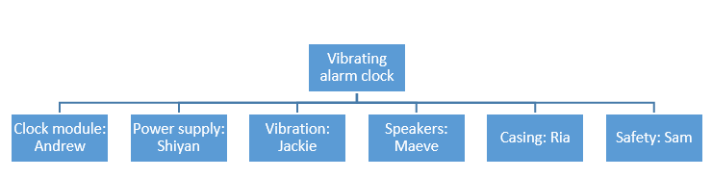

## Subsystem 1: Clock Module

To run the main internal clock, a microprocessor would be needed. By researching what product would best fit our needs, we found two processors that were optimal for prototyping: the Arduino and the Raspberry Pi. We selected the Arduino Uno, Figure 14, because our team lacked coding skills and the Arduino’s coding program was designed for programming beginners. Also, the Raspberry Pi was overpowered for our applications.

Figure 14: Arduino Uno

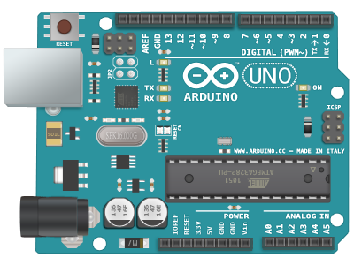

We searched online for a base code that we could add to and modify to fit the specific needs of our project [8]. From this base code, we altered the main alarm associated with the system to work with our vibration motors instead of the intended speaker. Then, we added a separate part to the code to make the failsafe buzzers sound a set time after the vibrating motors began. For testing purposes, we set this time difference to be 30 seconds in order to efficiently test the connected subsystems (vibration and speakers) in a short amount of time.

The display for the clock module was a 16x2 LCD screen, shown in Figure 15. This LCD screen displayed the time and what setting the clock was in (i.e. Set Alarm, Set Time, or running time).The time and alarm were set by using a combination of pushbutton switches shown in Figure 16. Two different buttons determined whether the time or the alarm was being set, and another set of two buttons determined whether the hour or minute for each mode was being changed.

|  |  |
| --- | --- |
| Figure 15: 16x2 LCD ScreenRelated image | Figure 16: Pushbutton SwitchImage result for radioshack submini push button |

## Subsystem 2: Vibration

To make the pad of the alarm clock vibrate, we used 5 vibrating motors. After looking at the different motor options, we elected to use LilyPad Vibe Board motors [7]. An image of the motors used is included in Figure 17. We chose these motors for several reasons. The first was for their small size. The low profile of the motors prevents feeling the motors as lumps in the pad that would be uncomfortable for the user to sleep on. Out of all the motors we compared within our price range, the LilyPad motors had the most significant power. These motors can take up to five volts, and they vibrate at their maximum potential when they get at least three volts. To verify if the seller was reputable, we looked at the reviews of the product and found that most customers were satisfied with their purchase.

Figure 17: LilyPad Vibe Board [7]

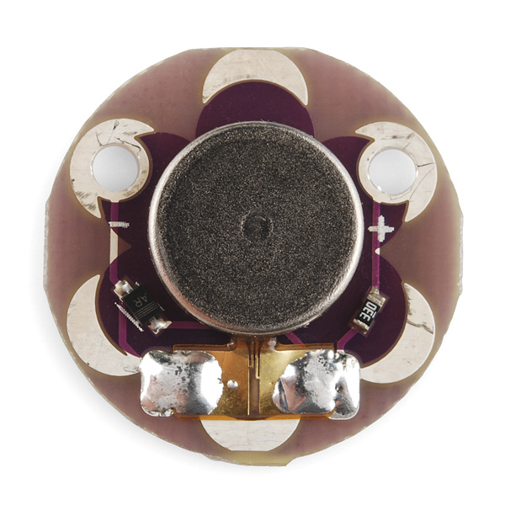

We wanted to make sure that the motors we selected could hold up to being slept on without being damaged. The LilyPad motors are designed for wearable devices, so we thought that would make them a good fit for our project. The plastic disk the motors are mounted on helps to distribute any force applied and makes the motors less likely to be damaged. Our choice of motor was based on the customer requirements we set for the system: comfort, effectiveness, and durability.

The motors were wired in series and secured inside of the pad. We initially connected them in parallel, but it was later determined through repeated testing that connecting the motors in series would result in a better performance. Wiring in series allowed the motors to receive enough voltage while appropriately limiting the current to allow the motors to vibrate at their maximum potential without damaging them. The motors were arranged in a circle, with 2-3 inches between each of them to concentrate the vibration to one location.The motor arrangement in the pad can be seen in Figure 18. Optimally, the location of the motors in the pad would be under the user’s upper back, near their shoulders, because we believe that is where they would be best felt, due to the protruding shoulder bones.

Figure 18: Vibrating Motor Arrangement

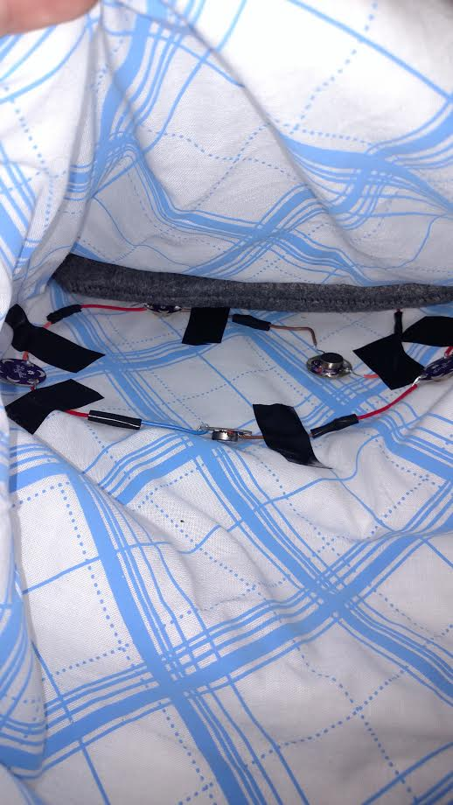

## Subsystem 3: Speakers

Our concept design included speakers that sound after the vibrating motors to assure the user is awakened. We wanted the speakers to have a range of 45 – 80 dB and be able to be incorporated into the pad that is slept upon. We also had to evaluate cost and did not want to spend more than $10 on the speakers in total. After researching different types of speakers, we chose to use piezoelectric buzzers. A main strength of these buzzers is some, unlike other types of speakers, do not require a square wave input to create a tone [9]. Indicators contain a circuit board that generates the square wave. This allows a DC voltage to directly be applied to the buzzer and results in a tone. The buzzers have a very limited tone range and have a set value for minimum decibel output, but they are also very durable, compact, and hard to overload [9]. One of the main concerns about choosing and testing the speakers was that it could possibly receive too much power and blowout. The piezoelectric buzzers we found had a large range of acceptable input voltage, and for this reason, we felt comfortable testing them very often without fear of ruining them. Piezoelectric buzzers can be bought as only the plate or in a full plastic housing. We chose to use ones that are already cased to prevent the piezoelectric element from being bent or otherwise damaged while in the pad.

We initially ordered two indicator piezoelectric alarm buzzers 1.65 inches in diameter and 0.3 inches in height, shown in Figure 19. These buzzers are powered by DC 5-15 V and were 90dB [14]. The buzzers proved useful for testing and initial prototyping because they were readily available, but we decided that they would not suffice for the final prototype. The measurements were considered before ordering and thought to be reasonable, but once we received them and had hands-on experience, we concluded they were too large. They could clearly be felt through the pad and that meant they did not meet our customer requirement of the pad allowing normal, comfortable sleep. We also found that 90dB was too loud and hard to work with to meet other customer needs. The buzzers also produced a fluctuating siren-like noise instead of a single tone as advertized.

Figure 19: First Buzzers Ordered [14]

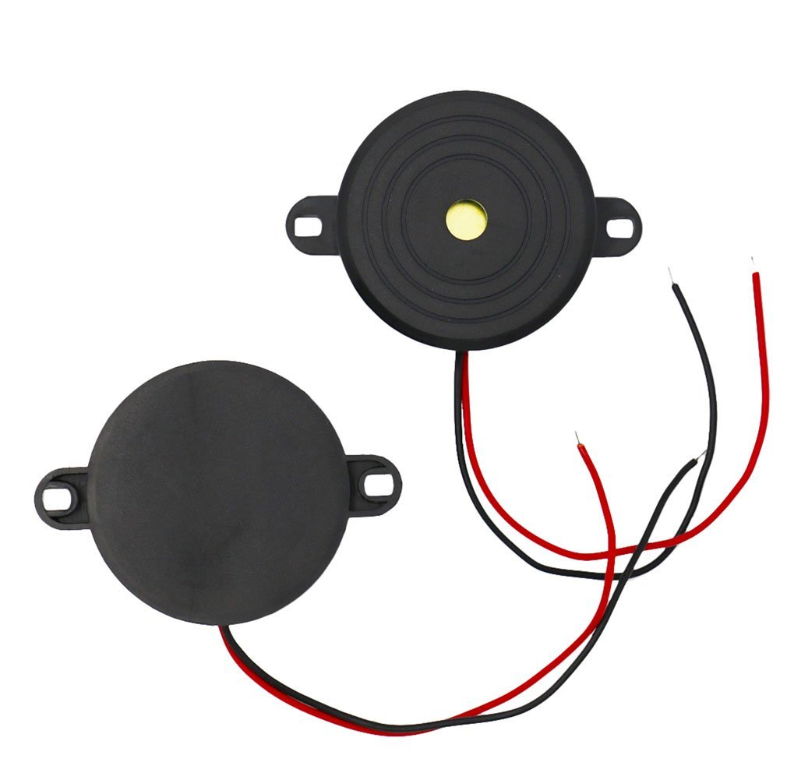

We ordered a second set of speakers after carefully evaluating what we had gathered from the first set. The new speakers measured only 0.9 inches in diameter and 0.38 in height, as seen in Figure 20[16]. Despite the fact that these buzzers were actually thicker than the first ones, they were easier to cushion and were felt less through the pad due to the decrease in diameter. The smaller diameter also meant there was less surface area touching the pad, and therefore the user was less likely to come in contact with them at all. The buzzers operated at 1.5 – 28 DCV, allowing us more possibilities with the circuit and the option to divert necessary voltage to the motors [16]. These speakers were used in our final prototype.

Figure 20: Second Buzzers Ordered [16]

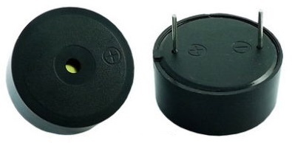

The buzzers were tested when they initially arrived to make sure they met specifications. Multiple tests of proving power confirmed the speaker volume and tone prior to incorporating them into the circuit. This was evaluated by a computer application that records decibels and frequency using a microphone at 4 inches away. We were confident in the lifespan and durability of the buzzers, so they were continuously tested in the circuit. This allowed multiple systems (the code, circuit, and speakers) to be checked to evaluate each subsystem and the successful integration into one working unit.

Since the buzzers had a set minimum output of 85 dB, we chose to create housing for them that would provide sound insulation. This housing would also cushion the speakers to protect them and to make them less noticeable through the pad. The user would be able to select the needed volume by altering the casing, and the casing would fit inside the pad with the vibrating motors. We had already exceeded the goal cost by ordering two sets of speakers, so we made sure to find the most cost efficient materials to use as insulation and adapted existing products to fit our needs to reduce manufacturing cost.

Figure 21 shows how the speakers were attached to a quilted fabric. The blue cushion was created by modifying oven mitts and allowed the speakers to be secured in place. This eliminated the possibility of the speakers sliding within the pad or flipping over since the cushion fit securely within the width of the pad. The overlay of material in between the speakers created a thicker surface so that the buzzers did not create raised lumps in the pad. This cushion was placed inside a grey case with pockets in it, shown in Figure 22. The case was made out of felt as it is an easily available material, is very low cost, and provides extra cushioning. When inserted into the case, the cushioned speakers’ location aligned with the green pockets. The user can effectively control the buzzer alarm volume by adding or removing silicone inserts from these pockets. Silicone pads were chosen because they were flexible, provided sound insulation, were cost efficient, and offered another level of safety. If the buzzers were ever to malfunction and heat up, the silicone pads would insulate the heat and prevent it from harming the user.

|  |  |
| --- | --- |
| Figure 21: Internal Speaker Cushion | Figure 22: Case with Pockets and Insulating Pads |

Once the prototype was fully assembled, the speaker system was tested using the same computer app mentioned before. With three inserts in each pocket (the maximum amount), the resulting volume was 53 dB. Without any inserts, it was 80 dB. Moving the microphone within 1-4 inches of the speakers in the pad did not have a noticeable effect on the volume. We met the upper range of our customer requirement for volume, but we didn’t fully meet the lower range. We felt this was acceptable because the pad was to be placed under a fitted sheet which would add an additional layer of insulation. The user also has the ability to choose the placement of the pad on the bed. Depending on the location, the distance of the speakers can also affect the volume the user hears.

## Subsystem 4: Safety

Due to the placement of the vibrating motors and speakers in the user’s bed, safety was a major concern for this project. The vibrating motors, speakers, and bare wires at solder points could have led to electrical fires in the pad if the wrong material was chosen. Material selection, wire insulation, and temperature control were the main goals of this subsystem. The pad material was chosen based on its heat and moisture resistant properties. Heat resistant properties were needed to prevent the user from being affected by any heat given off by the motors or the wires. Moisture resistant properties were needed to protect the components inside the pad from any moisture the pad may come in contact with, such as sweat from the user. Based on the needed parameters, an ironing pad was chosen as the pad material.

Fire hazards were one of the top concerns since they could be caused by multiple sources in the pad. Multiple wires were stripped and soldered together, so all bare wires at solder points had to be insulted with electrical tape or were crimped together. The wire contact points for the motors and speakers were also insulated after all points had been connected and tested. The wires in the pad were connected to the Arduino and breadboards via long wires that were crimped together. These four wires were encased in a hollowed out piece of 120 volt wiring, 6’ in length. This provided insulation for the smaller wires for the distance they extended outside the pad. It also protected the smaller, weaker wires from accidental stripping. Figure 23 shows the yellow external wiring exiting the top of the pad.

Figure 23: External Wire

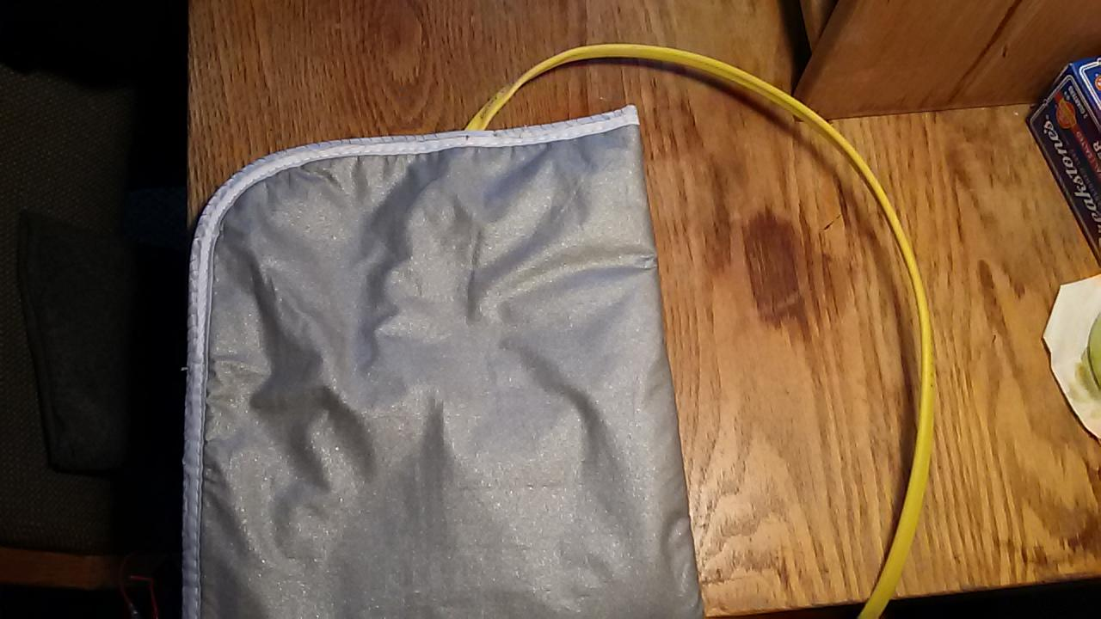

Inside the wooden clock casing, exposed metal, solder points and male pins were insulated with electrical tape to eliminate fire hazards. The bread boards and Arduino posed less of a fire hazard since each only contain female pins instead of solder points, unlike the LCD screen. The wood around the opening for the LCD screen was insulated with electrical tape, since the outer edges of the screen circuitry had wires soldered to bare metal.

With all points insulted in both the pad and casing, temperature was the only remaining safety concern. Throughout testing, the temperature of both the interior and exterior of the pad and casing were monitored to ensure that the operation of all of the components would not overheat and cause a fire.

## Subsystem 5: Power supply

For building a small electronic device, finding the right power source and providing it to the device is critical. The first task for this subsystem was to acquire the power supply for the microprocessor. The microprocessor Arduino Uno that we used in our design operates when supplied with 6V – 20V DC voltage. However, the microprocessor only operates normally under 7 – 12V. Any voltage under 7V would cause the board to become unstable and not able to produce consistent signal. Any voltage above 12V would overheat the board and risk damaging the processor [2]. For our project, we salvaged a 12V DC power adapter, seen in Figure 24, from a massaging pad from one of the group members. Although it was originally used to power a completely different product, it served as a good power source to our Arduino Board.

Figure 24: DC Power Adapter for Arduino

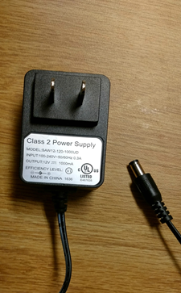

The second item on the agenda for power supply was to find the right way to implement the speaker system. For the speaker system, the original design was to put the pair of speakers in parallel and connect them directly to the digital output of the Arduino (5V output [3]), so that each of the speaker would receive 5V. After we received the speakers, we performed several tests on the speaker, the setup for which can be seen in Figure 25.

Figure 25: Speaker Testing Using Analog Discovery Board

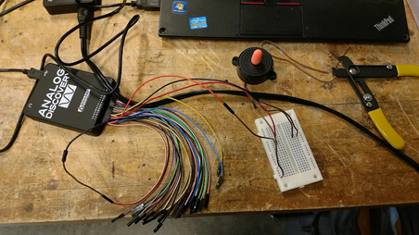

The setup resulted in the the speaker being loud enough even when each of them was only receiving 2.5V. This caused us to reconsider the circuit design for the speaker system. We changed the design to put two speakers in series, making them each receive 2.5V, while creating a small enough current to not fry the board.

The last and the most complex undertaking for the power supply subsystem was to implement the vibration system. The initial design was to use the Arduino board digital output to directly power the vibration motors. The motors function within the range of 0 – 5V [4]. After supplying the motor with different voltage, we discovered that the vibration intensity is based on the voltage that it receives. Our tests also showed that each of these motors has an internal impedance of 67 ohm, and the testing setup can be seen in Figure 26.

Figure 26 Vibration Motor Test

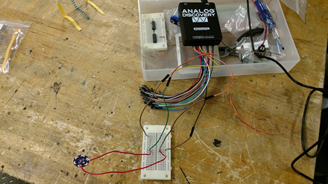

To ensure each motor received enough voltage, we designed the circuit in parallel. In a parallel circuit, the total resistance RT can be calculated using equation in figure 27.

Figure 27: Total Resistance Equation

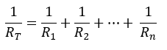

The total resistance of the design was calculated to be 13.4 ohm. This is a very small resistance that would result in a great amount of current. Further calculations were done using Ohm’s Law, which can be seen in Figure 28.

Figure 28: Ohm’s Law



With V being the voltage across the motor, R being RT, and I being the current in the circuit, the current generated in this circuit would equal 373 mA, which is much greater than the current limitation of the Arduino Uno board [7]. Later, we discovered that regardless how we changed the circuit, and even if we tried to use a secondary power supply, the current was still too great for any electronic switches (i.e. relay and transistor).

Consequently, we changed our design to instead connect the motors in series. A circuit diagram can be seen in Figure 29. There are two reasons we chose a series circuit: 1) the RT in a series circuit is the sum of all resistance, and with a total of 335 ohm of resistance, we would be able to get a current lower than the limit of the Arduino; 2) by using a secondary power supplies and electronic switches, we were able to isolate the motor circuit from the Arduino board itself, making it impossible to damage the board, the most delicate part of the prototype.

Figure 29: Circuit Diagram for the Final Design

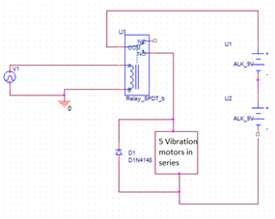

This circuit design allowed each motor to receive up to 3.6V, which exceeds the performance specification that we set for the vibration motor. The diode was included in the circuit to give the current a way to flow when the switch is open. This prevented the voltage generated by the inductance of the motor to break the relay.

The last problem we encountered was that we were not able to set the digital output from the Arduino to output a stable DC voltage, thus causing the relay to constantly switching on and off, lowering the actual DC voltage measured across the motors. Despite this, the each motor still received 2V, which was enough to make them vibrate significantly. The problem could have been fixed if we had had more time to learn how to send out a stable DC signal from the PWM.

## Subsystem 6: Casing

Several designs were considered for the outer casing of the alarm clock. The casing needed to contain all the intricate wires of the alarm clock and have an intuitive user interface of a display and buttons. To select the material the casing would be made of, the cost, shape, size, durability, aesthetic, weight, texture, and fabrication cost were all considered.

The material costs were first considered. From customer survey responses, the maximum the average user would be willing to spend on such a product was $20. Additionally, this was the alpha prototype we were creating, and as college students, a cheap solution was desired. This solution would have to be able to reflect that when produced for the market. As such, expensive options like aluminum sheets were removed.

Next, shape was decided. Again, there exist a number of fun alarm clock designs. However, this team decided that the durability of the clock was the principal concern due to potential aggressive slapping in the early morning by groggy users. This meant that designs going for aesthetic enjoyment were eliminated unless the shape was also stable. Additionally, the casing was designed to be unobtrusive and fit at the corner of a nightstand in such a way that did not bring attention to the clock. The final design was a simple rectangular prism.

After this, fabrication technique was evaluated. Many resources were at our disposal to create the casing. Our options included 3D printing, laser cutting, injection molding, and using the wood/metal-working shop. Again, the goal of the total cost being under $20 had to be considered . If mass produced, the creation technique had to be simple and fast. A 3D printer offered a chance to create a single body design, however, the plastic used in the filament is expensive, brittle, weak, and the building technique takes several hours with high chance of failure. The wood/metalworking shop could have allowed for construction of the material. However, to this, the consideration that labor costs would increase if any precision was to be desired eliminated it as a possibility. It would have been possible to create a mold, however, this is a time consuming process until a mold is made and is ideal for mass production, not for a single prototype. Additionally, it is incredibly easy to leave imperfections in the body of a case using this technique, considering our current skill level, attempting to create such a cast would leave us with a costly, amateur looking, and potentially fragile product. This left the laser cutter.

The laser cutter was the ideal choice because it would allow for the sides of the box to easily be cut well within the size wanted. The cutter available could handle thicker materials, allowing for durability. Material considerations were still between plastic and wood at this point. Plastic in thin sheets cut faster, but would make for more flimsy material that could melt if the internal temperature of the alarm clock got too high. If thick plastic was cut in the laser cutter, there was a high chance that the plastic would melt or catch fire or create noxious fumes. Wood on the other hand could be cut to a more sturdy thicknesses. Additionally, it could withstand higher temperature changes without melting.

The final decision was to use ¼ inch thick wood to create a rectangular prism that would be 3”x5”x7.5”. This size was determined by the amount material going into the box. All of the wiring components and electronics had to have enough room to be comfortably and easily put inside without too much work, again to keep real life manufacturing costs low.

Joint design was important. Woodworkers have created hundreds of types of joints that range from simple to sophisticated. Figure 30 shows different joint types considered for this box. Horizontally from top left to bottom right: butt joint, biscuit joint, bridle joint, dado joint, dovetail joint, finger joint, lap wood joint, mortise and tenon joint, rabbet joint [15].

Figure 30: Different Wood Joints

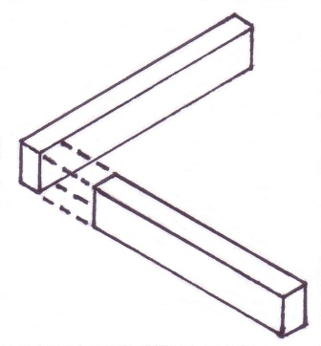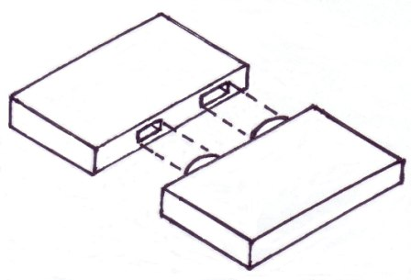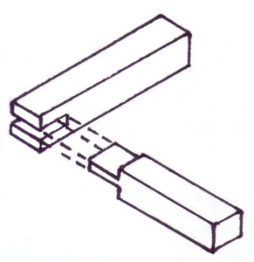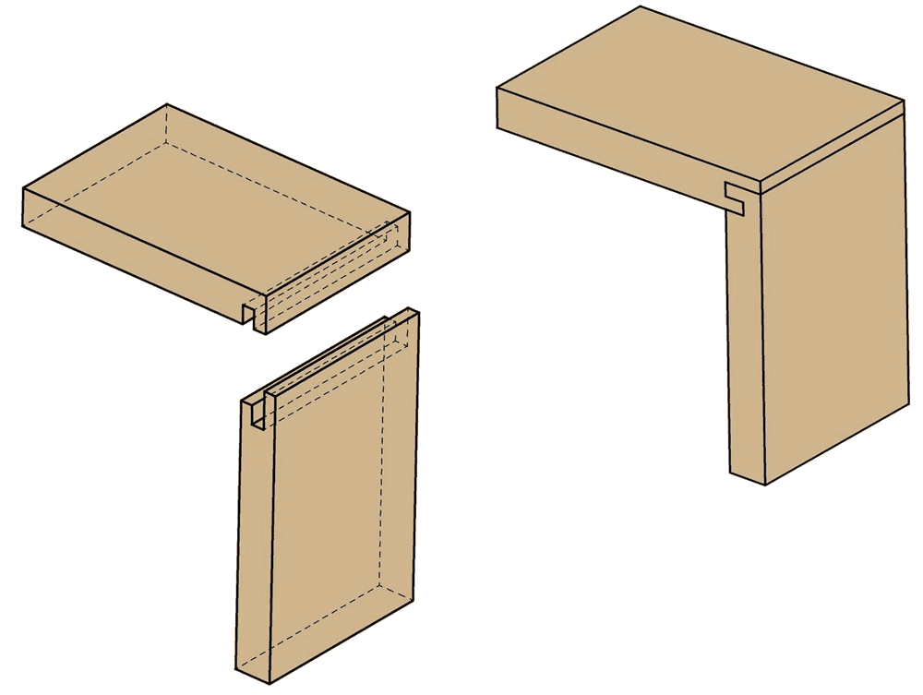

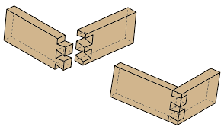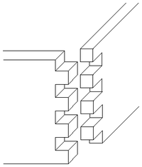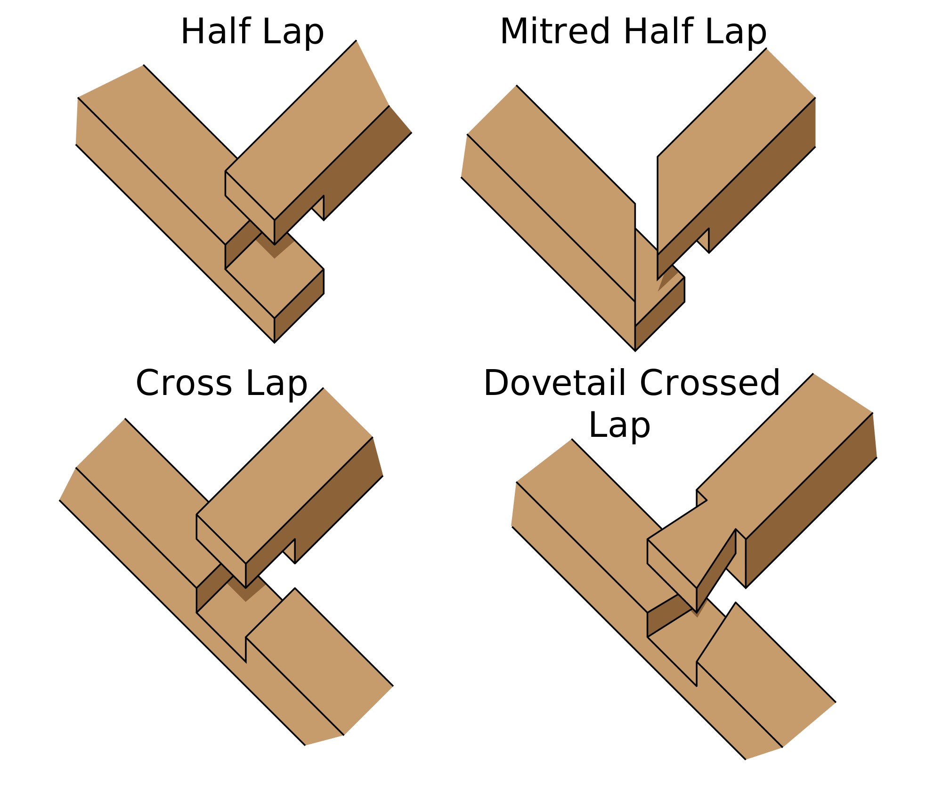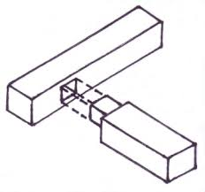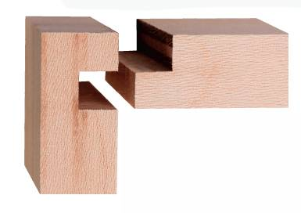

From these designs, a selection was made based on facility of creating the design in Adobe Illustrator, strength of joint, and lack of need for extra support. Each of these joint types had benefits and flaws that can be understood from reading the descriptions created by numerous woodworkers. For example, the butt joint is incredibly weak and always requires additional support. Dovetails were the most famous joint type, however, with the angled shape of the pieces, there is a high chance of breakage of the pieces. Instead, finger joints were selected. These joints created a high degree of friction between pieces of wood, had a regular pattern making it easy to draw in illustrator, and created a symmetrical checkered pattern when pushed together. No wood glue or other extra support would be needed for our our box if the joints were made to be perfect fits. Figure 31 shows the Adobe Illustrator drawing used to laser cut the box. Variations were made to sides including a cut out for the screen display on only one side. The final clock casing is shown in Figure 32.

Figure 31: Casing Illustrator Drawings

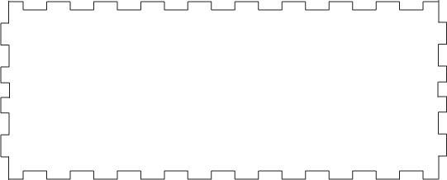

Figure 32: Final Appearance of Clock Casing

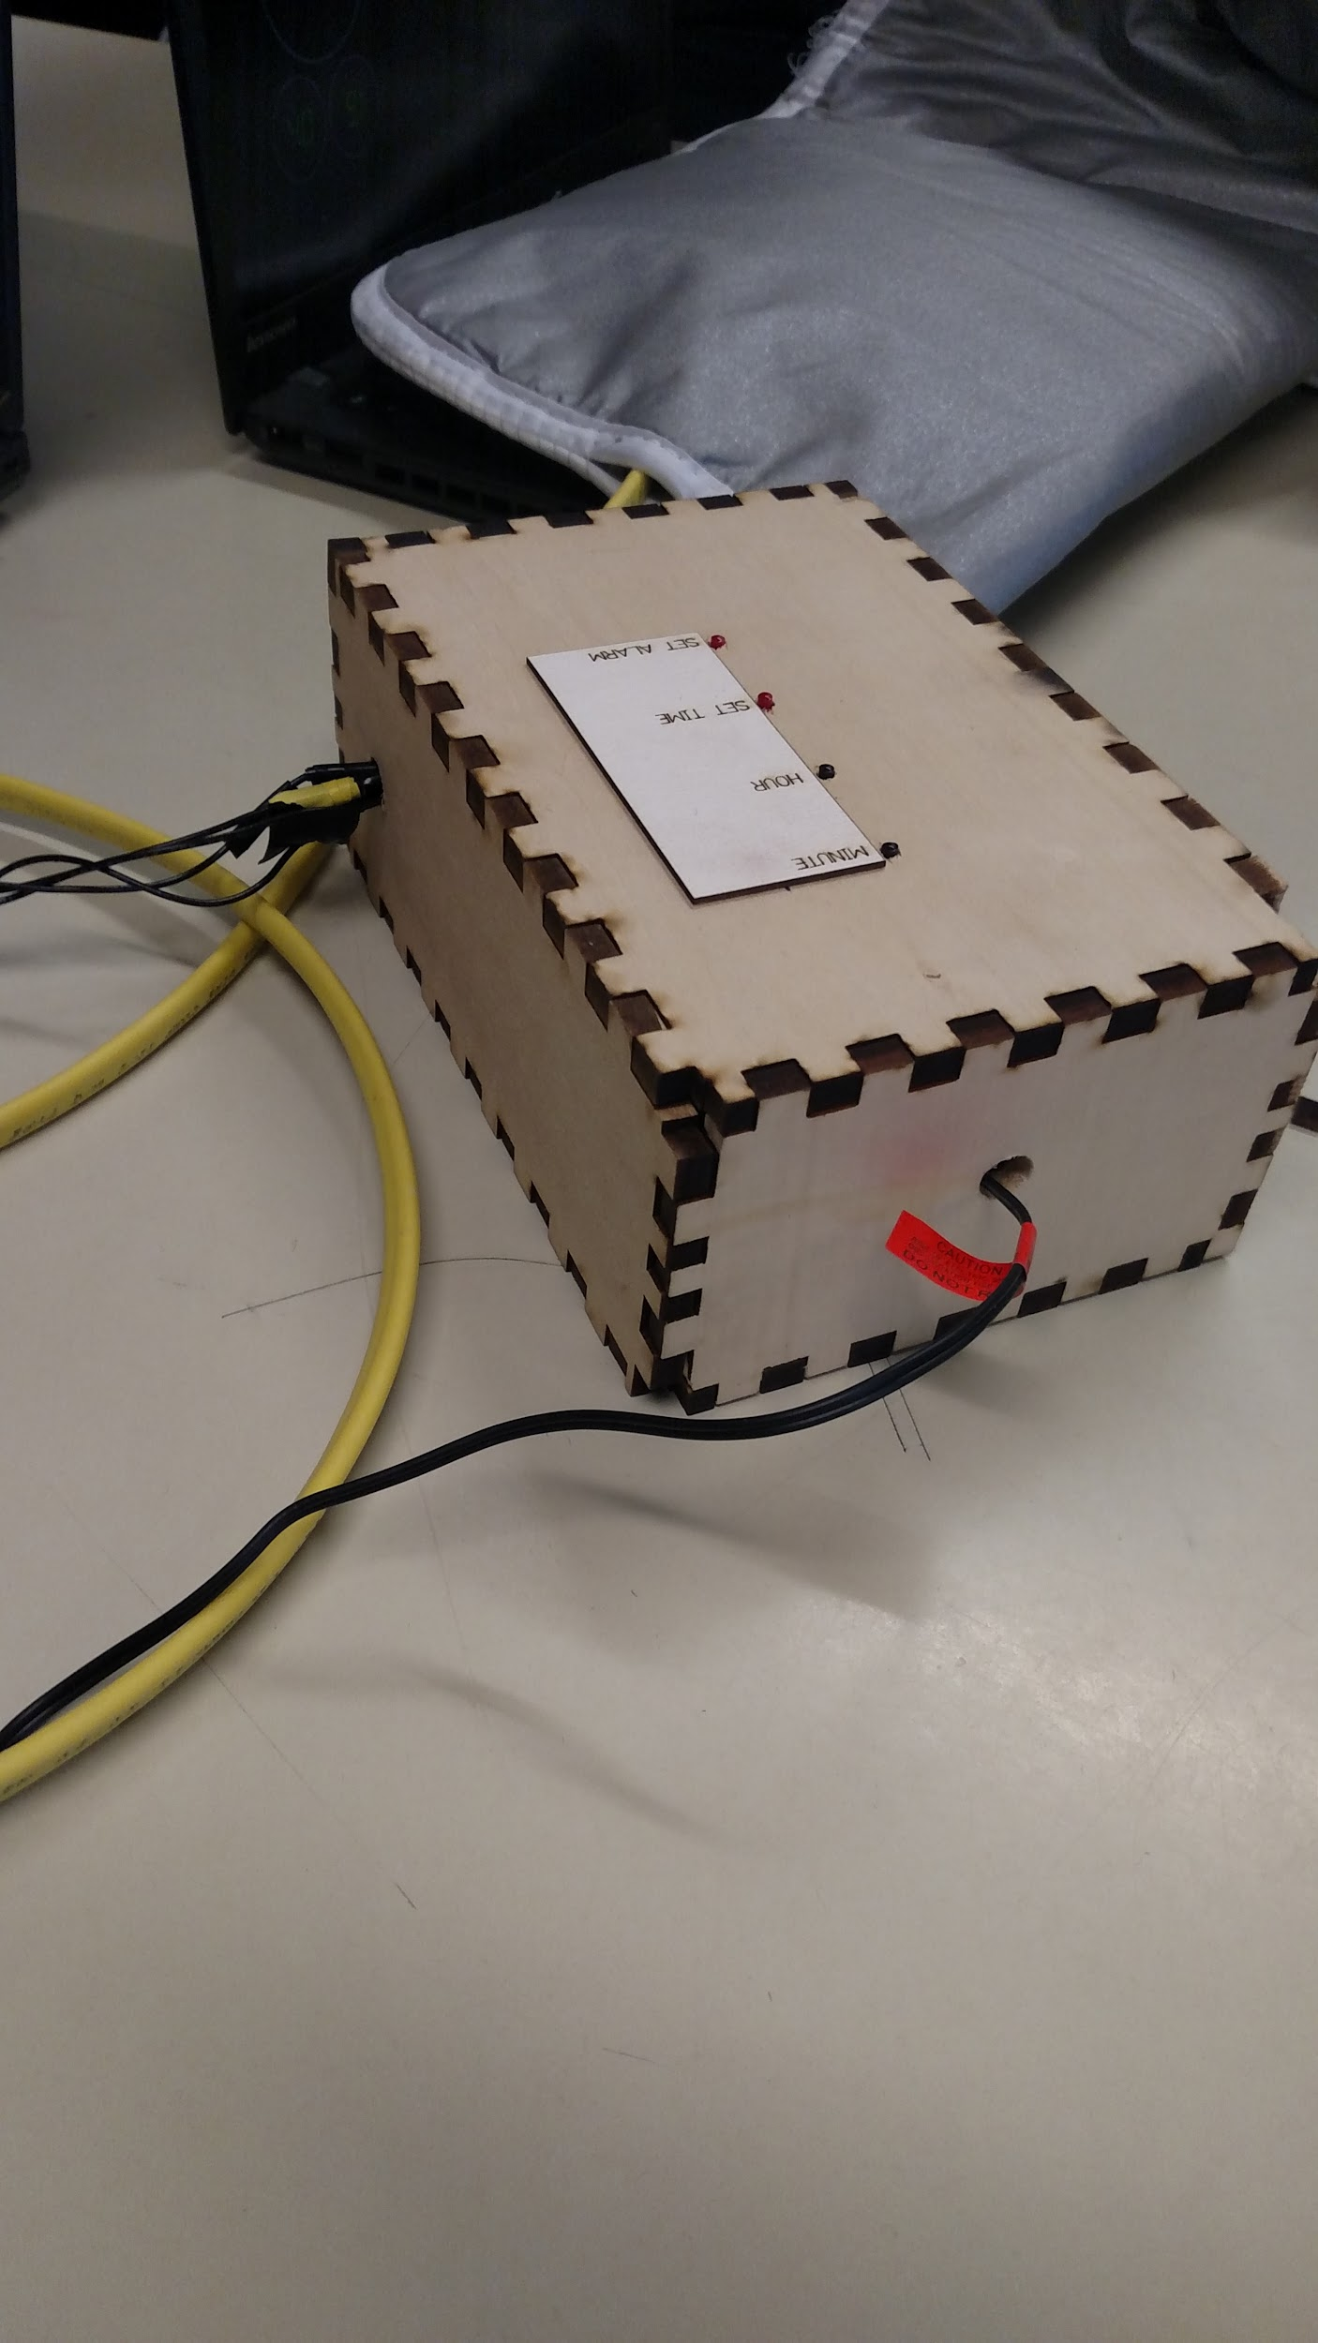

The final casing used for the prototype had sturdy joints that fit and stuck without glue. However, the piece of wood used had a strong grain that lead to some pins breaking off. In a future iteration, the pins can be made wider to have more of an interface with the rest of the piece of wood. There is enough friction that the approximately quarter inch pins could be enlarged to ⅜ inch pins. Also, the corners should have much more of an attachment to the rest of the wood in a future design. Other than the few snapped off pieces, the wood box cut perfectly to size for all parts and had a sturdy design that withstood much more than the 10lbs specified for the class demonstration. It can withstand small drops, hard and quick hits as one would hit to snooze the alarm, and up to 50lbs of pressure when measured on a scale. The words are also clearly visible.

# Results and Discussion

## Results

On demonstration day, each subsystem met the technical specifications that were set for each of them. To ensure this, we tested the clock multiple times in the days leading up to the demonstration and made sure that the subsystems met their requirements each time. One problem that was encountered during preliminary testing was that the motors were not receiving enough power. The motors were put in series instead of in parallel to correct this problem. Another major problem was that the vibrating motors weren’t shutting off once the speakers turned on, which took away power from the speakers. This was corrected by rewriting the code multiple times until the motors stopped vibrating once the speakers turned on.

During the class demonstration, the power subsystem met the technical specification since all parts of the clock received power. The casing subsystem showed that the clock was durable by weighing the clock on a scale and then applying 10 lbs of force by pushing on the top of the alarm clock. The rest of the subsystems had to be tested during and immediately after the alarm sequence. When the vibrating motors started, a multimeter was used to measure the voltage drop across one motor. The technical specification required a minimum of 2V and 2.01V was observed during the test. After 30 seconds, the vibrating motors stopped and the speakers turned on, fulfilling the specification for the clock module. Simultaneously, the speakers’ output was measured with a computer application to be 65 dB, which was within the specified range of 45-65 dB. Finally, after the alarm sequenced stopped, the air temperature of the room was measured with a probe thermometer and the temperature of the pad and the electrical components of the case were measured with an infrared thermometer. The pad was only 1° F above room temperature and the electronic components were only 3° above room temperature.

While the clock ran multiple times, we were unsure how long the motors would be able to operate before they were burnt out or were broken by the user’s weight. A major future enhancement would be to find tougher motors that vibrate with more intensity and can handle more weight.

A future improvement that we did consider would be to incorporate a gradual light component into the clock casing. This idea was one that we had originally explored as the main alert component for the alarm, but it was eliminated because it would probably wouldn’t be as effective as vibrating motors. If we had more time and our budget was larger, we would install a gradual light component on the face of the alarm clock around the LCD screen.

## Significant Technical Accomplishments

The main obstacle of this project was the coding aspect of the Arduino, since no one in the group had extensive coding experience. Originally, we planned to use a clock module from an existing alarm clock and outsource any coding to a Computer Science student. However, once we got further into this project, we realized we would have to run all functions through the Arduino since the goals we had exceeded what a repurposed alarm clock circuit could do. Andrew was able to learn how to code on an Arduino on his own and then modified the code until he was able to get the motors to vibrate for a set amount of time and then trigger the speaker. As with most computer codes, many iterations were needed to finally get the functions to work properly.

Another major obstacle was getting enough power to the circuit with just the power output from the Arduino. This lead to our circuit and motor layout designs being changed multiple times until a solution was found. We concluded that putting the motors in series with an additional power supply of two 9 volt batteries corrected this problem.

These two main issues slowed the progress of the overall project since they were core components. Other subsystems were mostly complete by the time these two problem became apparent, so the group became nervous that we would not finish in time. By solving both of these problems, we were able to move forward and finish the project with new knowledge of circuits and computer science.

# Conclusions

The goal of this alarm clock was to create a peaceful environment in the dorm rooms and lower possible tensions between roommates that have conflicting sleep schedules. This product utilized vibration to effectively awaken only the user, leaving the roommate unaffected. In the event of sleeping through the vibration, a safety mechanism will engage and produce a directional sound that should only be heard by the user. The combination of vibration and insulated speaker should ensure a smooth and easy morning for anyone in the room.

We tried to take every customer requirement into consideration. The survey we conducted gave us feedback on what people would normally expect from a regular alarm clock and what they would want that isn’t already implemented. We built our prototype based on our first target customers: college students. The quietness of the alarm clock should meet the requirements for anyone not wanting to disturb their roommate/bedmate.

After careful benchmarking of existing products, we found that there is no similar product that provides quietness while remaining comfortable and effective to the customer. Therefore, we selected the concept of a vibration pad with speaker buried right below the user’s ears and beside the neck. The pad will be controlled with an Arduino Uno microprocessor with a stable 12V DC power supply. The clock module itself is contained in an elegantly designed, carefully laser-cut wooden box.

The team worked very cohesively when integrating the subsystems and we managed to solve most of the problems we met, a major one of them being not knowing how to code the Arduino. Andrew, a responsible teammate, stood up to learn the basic language for coding. Yet we were still unable to produce a stable DC-like signal from the PWM of the board.

The testing result of our prototype was satisfying: we met all the performance specification we set for ourselves. However, with the PWM issue, we were not able to maximize the voltage across the vibration motors, therefore we were not able to achieve the maximum effectiveness of our current system.

Many improvements could be made on this prototype if we were to put it into production. The first one is to customize a DC adapter that not only powers the clock, but also the vibration motors. This modification would free us from the limitation of the 2 9V batteries of the secondary power supply. Also, we could reprogram the output to the vibration circuit to allow a constantly closed relay in the vibration circuit.

As the project progressed, we carefully followed the timeline we set for ourselves. The team worked very positively together, and we all learned a lot from each other. By keeping a positive atmosphere, we were able to successfully finish our project within our budget and timeframe.

# References

[1]"Amplifyze TCL Pulse", Harriscomm.com, 2017. [Online]. Available: http://www.harriscomm.com/amplifyze-tcl-pulse-pink-bluetooth-vibrating-bed-shaker-and-sound-alarm-by-amplicom.html. [Accessed: 20- Feb- 2017].

[2]”Arduino UNO & Genuino UNO”. [Online.] [Available: https://www.arduino.cc/en/main/arduinoBoardUno](https://www.arduino.cc/en/main/arduinoBoardUno). [Accessed: 30-Apr-2017]

[3]C. Kalb, "Your Alarm Clock May Be Hazardous to Your Health", Smithsonian Magazine, 2013. [Online]. Available: http://www.smithsonianmag.com/science-nature/your-alarm-clock-may-be-hazardous-to-your-health-164620290/#hKLsFYFf0wiaDyWb.99. [Accessed: 05- Mar- 2017].

[3]”DigitalWrite”. [Online.] Available: <https://www.arduino.cc/en/Reference/digitalWrite> [Accessed: 30-Apr-2017]

[4]”Is there a limit on how much current a pin can sink?”. [Online]. Available:<https://arduino.stackexchange.com/questions/88/is-there-a-limit-on-how-much-current-a-pin-can-sink> [Accessed: 30-Apr-2017]

[5]"Is your alarm clock bad for your health?", Sites.psu.edu, 2015. [Online]. Available: https://sites.psu.edu/siowfa15/2015/09/16/is-your-alarm-clock-bad-for-your-health/. [Accessed: 06- Mar- 2017].

[6]J. Jones, "In U.S., 40% Get Less Than Recommended Amount of Sleep", Gallup, 2017. [Online]. Available: http://www.gallup.com/poll/166553/less-recommended-amount-sleep.aspx. [Accessed: 06- Mar- 2017].

[7]”LilyPad Vibe Board”. [Online]. Available:<https://www.sparkfun.com/products/11008> [Accessed: 15-Apr-2017]

[8]M. Dicienson, “Arduino LCD alarm clock,” *Fritzing*, 09-Aug-2014. [Online]. Available: http://fritzing.org/media/fritzing-repo/projects/a/arduino-lcd-alarm-clock/code/arduino_alarm_clock.ino. [Accessed: 14-Apr-2017].

[9] "Piezo and Magnetic Buzzers", Cui.com, 2017. [Online]. Available: http://www.cui.com/product-spotlight/piezo-and-magnetic-buzzers. [Accessed: 02- Mar- 2017].

[10]"Sharp Vibrating Pillow Alarm Clock", Amazon.com, 2017. [Online]. Available: https://www.amazon.com/Sharp-Vibrating-Pillow-Alarm-Clock/dp/B00N33YR1O. [Accessed: 20- Feb- 2017].

[11]"Silent Vibrating Personal Alarm Clock "Shake-N-Wake"", *Amazon.com*. [Online]. Available: https://www.amazon.com/Silent-Vibrating-Personal-Alarm-Shake-N-Wake/dp/B0027A573Q. [Accessed: 20- Feb- 2017].

[12]"Smart Shake", *Hearmore.com*, 2017. [Online]. Available: http://www.hearmore.com/store/prodView.asp?idproduct=15724&idstore=6&product=Smart-Shaker---White. [Accessed: 20- Feb- 2017].

[13]"Sonic Bomb Loud Dual Alarm Clock", Amazon.com, 2017. [Online]. Available: https://www.amazon.com/Sonic-Alert-SBB500SS-Alarm-Shaker/dp/B000OOWZUK/ref=pd_bxgy_201_img_2?_encoding=UTF8&pd_rd_i=B000OOWZUK&pd_rd_r=BTDEPJCZ45ENKX4G36WE&pd_rd_w=Jlr4g&pd_rd_wg=fuDiL&psc=1&refRID=BTDEPJCZ45ENKX4G36WE. [Accessed: 20- Feb- 2017].

[14]"SOOKOO 2 Pack DC 9-15V HYD-4218 Active Piezo Electronic Alarm Buzzer", Amazon.com, 2017. [Online]. Available: https://www.amazon.com/gp/product/B01JA7IX0M/ref=ox_sc_act_title_2?ie=UTF8&psc=1&smid=A3P8NZ3ZH7J0J5. [Accessed: 04- Apr- 2017].

[15] “WOOD JOINTS: WHICH WOODWORKING JOINTS SHOULD YOU USE?”, Woodworkers Guild of America. [Online] Available: <https://www.wwgoa.com/article/woodworking-joints-which-ones-should-you-use/?nabc=0&nabe=5597362638815232:1&utm_referrer=https://www.google.com/> [Accessed: 30- Apr- 2017].

[16] “2 x PIEZO ELECTRONIC TONE BUZZER ALARM 1.5-28V PCB”, Ebay.com, 2017. [Online]. Available: http://www.ebay.com/itm/221778802867?_trksid=p2057872.m2749.l2649&ssPageName=STRK%3AMEBIDX%3AIT. [Accessed: 12- Apr- 2017].

# Appendix A: Selection of Team Project

When trying to choose a project, our group began listing as many problems as we could think of. As students, with limited skills, time, and budgets, there were some problems we clearly couldn’t tackle. We narrowed our list down to several problems: sleep, cleaning, getting objects up stairs, disaster relief, snow getting stuck to boots, and accessibility for people with disabilities. These problems are outlined and described in Figure 33 below.

Figure 33: Potential Problem Descriptions

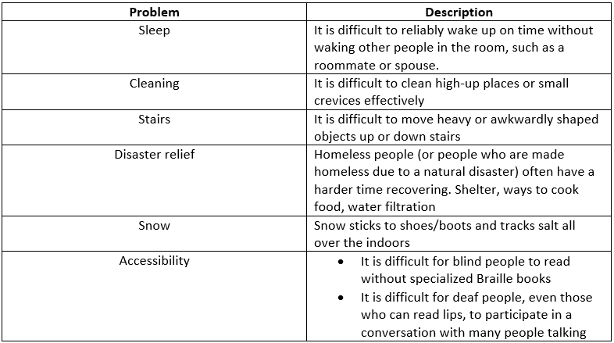

We researched each of these problems to try to come up with ways they could potentially be solved and see what solutions already existed. We found that for a couple of these problems, like cleaning and stairs, we couldn’t think of many ideas beyond what we found already existed. We liked the idea of a way to get snow and salt off of shoes, but we had trouble thinking of any practical solutions that could be broken up into six subsystems. That left us with sleep, disaster relief, and accessibility. We found lots of information and resources when researching disaster relief, but the scope of the problem seemed over our heads. Along with that, there were existing portable shelters and water filtration devices, and we didn’t think we could effectively improve them or make them more cost efficient. We had many ideas that could help people with disabilities. We were excited about these ideas, but while discussing them we realized that they were out of our skill range, as they were all heavily based on coding. Our group did not have anyone with coding experience in it, but we did have people with mechanical and some electrical experience. We concluded that the sleep problem was the best fit for our group’s skill set.

Once we decided to solve the problem of waking on time without awakening others in the room, we started thinking about how that could be done. First we thought about the many ways to awaken a person. The six main methods we thought of were: having a gradual increase of brightness to mimic a sunrise, shaking the bed, a vibration felt by the user, pulling off the blankets, a loud noise, or an increase in temperature. To decide which of these methods was best for our project, we came up with four categories on which to judge each method. The categories were how effective the method is, whether or not it would disturb or wake others in the room, how safe the method is, and how pleasant it would be to wake to. We used a concept selection matrix, which can be seen in Figure 34, to help us evaluate each of these methods against each other.

Figure 34: Concept Selection Matrix

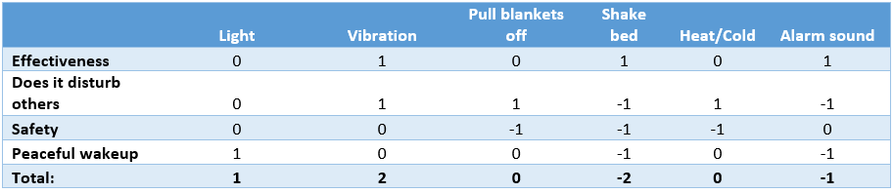

We determined that light and pulling off the blankets would not always be effective in waking the user, but the rest of the methods would be effective. With light, it would be simple for the user to roll over to face away from the light and ignore it, and not everyone sleeps with blankets or keeps them on all night in the first place. The problem we wanted to solve with our project is a way to waken without waking others, so whether or not each method would disturb the sleep of others in the room was very important in our choice. We concluded that a loud noise and, depending on the intensity, bed shaking would disturb others in the room. Safety was also a high priority, we wanted to make sure people would feel comfortable using our project and that no one would get hurt. Increasing the temperature would pose a safety risk due to having heating elements in a bed with flammable material like bed sheets. We also thought that depending on the intensity, causing the bed to shake could also be a safety risk, as could pulling off the sheets, if it were to use a mechanical system that would be in the bed. Last, we judged how pleasant each method would be. Light would definitely be the most pleasant way to wake to, as mimicking a sunrise would lead to a very natural transition between sleeping and waking. We decided that both shaking the bed and a loud alarm tone would be very unpleasant to awaken to, and all of the other methods would not necessarily be pleasant or unpleasant.

After considering all of the methods and looking at the results of the concept selection matrix, it was clear that vibration was best for our project. It would be effective in alerting the user, yet it would not disturb others in the room. Vibration itself did not have any large safety concerns, and it wouldn’t be too unpleasant to awaken to, leading to less dread of waking up in the morning.

# Appendix B: Customer Requirements and Technical Specifications

This project mainly focused on one consumer group: college students. However, our product could have multiple groups of customers that would benefit from it.

Possible Customers:

* College students
* Anyone sharing a room
* Hearing impaired
* Partners sharing a bed
* Parents with young children sleeping nearby

Stakeholders in this project included team members, our IED professors, competing alarm clock companies, and employers who expect employees to wake in time for work.

As mentioned in section 2.2, a poll was conducted to gather information on our target audience. The poll and responses are included in Figure 35.

Figure 35: Complete Survey and Responses 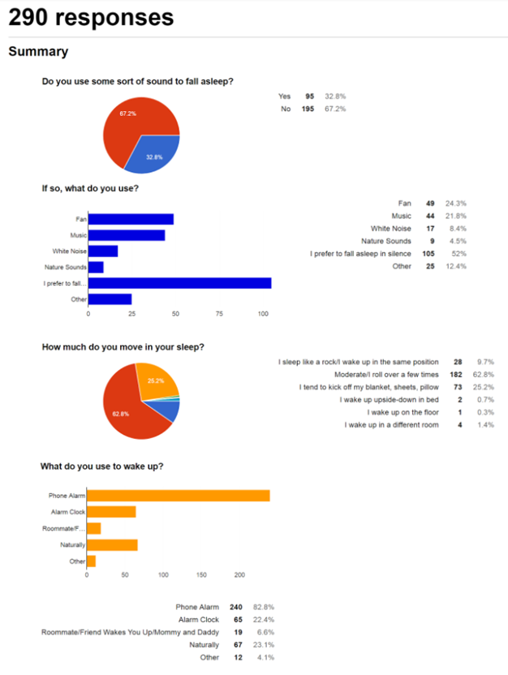

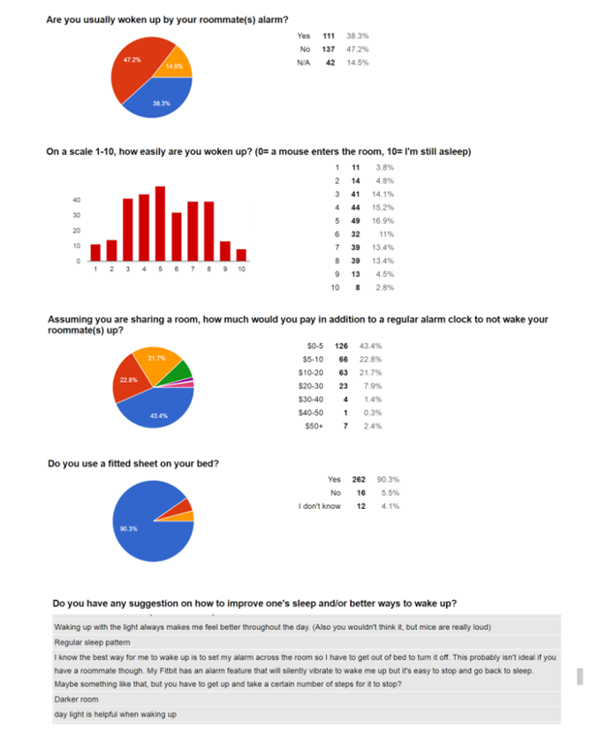

Figure 36 is a sample of the customer data templates we used. It has the detailed information from an individual’s interview. We used the same template with the same questions for all interviews conducted.

Figure 36: Customer Data Template

|  |  |  |
| --- | --- | --- |
| **Customer:** Brian Mottola  3/5/2017 | | |
| **Question / Prompt** | **Customer Statement** | **Interpreted Need** |
| **Do you use an alarm clock? What type of alarm do you use? How do you use it?** | I usually wake up on my own, but I use one if I need to make sure I’m up early | The alarm clock is reliable. |
| I use my phone with sound and some vibration | The alarm clock has vibrations and/or sound. |
| I put it on my bed next to my pillow | The alarm clock can be used on the bed. |
| **What do you like about your current alarm?** | It isn’t so loud it bothers my roommate | The alarm clock does not wake others in the room. |
| I always have my phone, so it’s convenient | The alarm clock is easy to use. |
| I can choose between vibration and sound depending on the importance of the alarm | The alarm clock is customizable. |
| **What do you dislike about your current alarm?** | My phone has died during the night if I forget to plug it in or accidentally unplug is during the night | The alarm clock has consistent power. |
| The alarm sounds like a phone call | The alarm clock is distinguishable from other stimuli. |
| **Do you have any suggestions to improve your alarm or suggestion for a different alarm system?** | Would like a better snoozing mechanism. My phone is hard to swipe | The alarm clock has a simple snooze control. |
| Have stronger vibrations | The alarm clock wakes the user by using vibrations. |
| Maybe have a way to attach it to the bed or something | The alarm clock is secured. |

Figure 37 has the collection of information from all of our customer data templates. Responses were grouped by each section to allow easy reference. Technical Specifications are included for needs the team chose to address and are only listed the first time the need occurs. If the need occurs again, it is referenced by numbers in brackets. An X means the team decided to exclude that customer requirement.

Figure 37: Combined Customer Data

|  |  |  |  |
| --- | --- | --- | --- |
| **Combined Customer Data** | | |  |
| **Question / Prompt** | **Customer Statement** | **Interpreted Need** | **Technical Specification** |
| **Typical Uses** | I only use my alarm if I have a test in the morning | The alarm clock reliably wakes the user. | <5 % sleep through (1) |
| My first class is at 2 so I usually wake up without an alarm | The alarm clock can be used at any time. | Clock runs continuously for >24 hours (2) |
| I have to get up for 8am classes | The alarm clock reliably wakes the user. | (1) |
|  | I need to be awake early so I don’t miss physics quizzes | The alarm clock reliably wakes the user. | (1) |
|  | I use my phone as an alarm for the morning but also for naps | The alarm clock can be used at any time. | (2) |
|  | Setting my phone alarm is more reliable than asking someone to wake me up | The alarm clock reliably wakes the user. | (1) |
|  | I use two alarms on my phone with different songs so I know when I really need to get out of bed | The alarm clock is customizable. | Volume of speakers can be chosen by user from 45-80 dB (3) |
|  | I’ve knocked my alarm clock to the floor while violently searching for the snooze button | The alarm clock functions normally if dropped. | X |
| **Likes** | Fitbit's vibration alarm is quiet and effective | The alarm clock only wakes the user. | (3)  Sleepers in room disturbed <5% of the time (8) |
| My alarm clock is simple | The alarm clock is easy to use. | <5 buttons control clock functions (4) |
| I know what each button does | The alarm clock controls are clearly labeled. | Each button is labeled with its corresponding function |
|  | I can take my clock with me to hotels and stuff | The alarm clock can be used in multiple locations. | Clock is not permanently installed |
|  | It’s pretty cheap | The alarm clock is cost efficient. | Prototype cost <$75 |
|  | Setting the alarm is very intuitive | The alarm clock is easy to set. | (4) |
|  | My phone is quiet enough to wake me for early morning ROTC things without disturbing my roommates | The alarm clock only wakes the user. | (8) |
|  | I’ve taken my alarm clock camping and it doesn’t stop working if it gets wet | The alarm clock is weather resistant. | X |
|  | I can put my phone in my pillowcase to make sure I hear the alarm | The alarm clock can be positioned by the user. | Cord length of 3-5 feet |
|  | It hasn’t killed me | The alarm clock is safe. | 0 casualties |
| **Dislikes** | Being jarred awake by a loud siren-like alarm is never fun | The alarm clock is pleasant to wake to. | 5 vibrating motor running with >2V (6) |
| My Fitbit has an alarm feature that will silently vibrate to wake me up but it's easy to stop and go back to sleep. | The alarm clock is hard to ignore. | (3) (6) |
| Gradually increasing volume instead of sudden noises makes for a more pleasant wake up | The alarm clock has a gradual alarm system. | Speakers sound 30 seconds after vibrations start (7) |
|  | I have a hard time reading the screen when I don’t have my glasses | The alarm clock screen is easily read. | Screen size at least 1x2 inches |
|  | I need a nightstand to put my clock on | The alarm clock can be used without a nightstand or other table. | X |
|  | My clock resets if I lose power | The alarm clock has a battery backup. | X |
|  | It’s easy to knock my phone off my bed and then miss the alarm | The alarm clock is secured in place. | Pad secured under fitted sheet moves <2 inches through night (5) |
|  | I can’t feel my phone vibrate if I push it too far away from me | The alarm clock system does not move during the night. | (5) |
|  | My alarm clock wakes my boyfriend up if he stays the night | The alarm clock wakes only the user. | (8) |
|  | It’s hideous | The alarm clock is aesthetically pleasing. | Wood clock casing |
|  | One of the buttons stopped working | The alarm clock can withstand force. | Withstands at least 10 lb |
|  | My roommate’s alarm clock screen blinks and it’s really annoying | The alarm clock is not distracting. | 0 blinking or moving external parts |
|  | My alarm clock went off one morning and my roommate left the room because he thought it was a fire alarm | The alarm clock is distinguishable from other stimuli. | Constant 41,000 Hz tone |
|  | I don’t wake up if I leave my phone on my desk | The alarm clock is secured in place. | (5) |
| **Suggested**  **Improvements** | A watch that vibrates in instead of making a sound | The alarm clock uses vibrations to wake the user. | (6) |
|  | Gentle vibrations, rather than waking up to a loud noise. | The alarm clock uses vibrations to wake the user. | (6) |
|  | Use a smart alarm clock app to wake up outside of REM sleep | The alarm clock tracks sleep cycles. | X |
|  | Wake up to the smell of food, real food | The alarm clock uses scent to wake the user. | X |
|  | Something that's able to sync with someone's sleep cycle would be great | The alarm clock tracks sleep cycles | X |
|  | My suitemate is notorious for not waking up, but she's recently gotten a smart watch that vibrates her wrist and it's pretty effective in waking her up | The alarm clock can wake heavy sleepers. | (6)    Speakers can reach 80 dB |
|  | Waking up with the light always makes me feel better throughout the day | The alarm clock uses light to wake the user. | X |
|  | I know the best way for me to wake up is to set my alarm across the room so I have to get out of bed to turn it off | The alarm clock is not easily ignored. | (3)  (6) |
|  | Daylight is helpful when waking up | The alarm clock uses light to wake the user. | X |
|  | A device to regulate the bed's temperature | The alarm clock controls bed temperature. | X |
|  | Get something that tracks your sleep so you wake up when you’re in the lightest stage of sleep | The alarm clock tracks sleep cycles. | X |
|  | Noise machines are nice | The alarm clock supplies white noise. | X |
|  | Blinds that automatically open that let light in when you want to wake up. (Synced with your alarm) | The alarm clock uses light to wake the user. | X |
|  | I sleep next to a window so natural light from the sunrise helps wake me up relatively early. | The alarm clock uses light to wake the user. | X |
|  | Some requirement to turn off alarm (ie having to get up, solve a puzzle, etc.) | The alarm clock is not easily ignored. | (3)  (6) |
|  | some sort of puzzle ensures i stay awake | The alarm clock is not easily ignored. | (3)  (6) |
|  | use natural light | The alarm clock uses light to wake the user. | X |
|  | Some kind of background noise can really help with sleeping | The alarm clock supplies white noise. | X |
|  | Customizable snooze options | The alarm clock has customizable settings. | (3) |
|  | Something gradual | The alarm clock has a gradual alarm system. | (7) |

Figure 38 has detailed needs listed in order of priority. This is the same information found in Figure 4 but reorganized instead by magnitude of importance. .

Figure 38: Prioritized Requirements

|  |
| --- |
| **Most Important** |
| The alarm clock has clearly labeled parts.  The alarm clock case can withstand use of controls without deforming.  The alarm clock case does not bend under small (10 lb) force.  The alarm clock can be installed quickly  The alarm clock is cost efficient.  The alarm clock is easy to reset.  The alarm clock can work on a variety of beds.  The alarm clock casing contains necessary electrical components.  The alarm clock casing does not become hot.  The alarm clock does not shock the user.  The alarm clock electronics are properly insulated.  The alarm clock does not cause a fire.  The alarm clock reliably tells time.  The alarm clock alarm time can be set by user.  The alarm clock initiates wake-up sequence at appropriate time.  The alarm clock is not heard by others sleeping in the vicinity.  The alarm clock does not interfere with the other bed in a set of bunkbeds.  The alarm clock only alarms at given time.  The alarm clock does not prevent certain sleeping positions.  The alarm clock uses vibrations to wake the user.  The alarm clock does not cause panic.  The alarm clock is distinguishable from other stimuli.  The alarm clock’s wires are contained/wrapped.  The alarm clock placement can be decided by user. |
| **Moderately Important** |
| The alarm clock screen is easy to read.  The alarm clock screen displays the selected function.  The alarm clock can be relocated.  The alarm clock casing has no sharp parts.  The alarm clock has a secondary way to ensure the user wakes.  The alarm clock is not distracting to others.  The alarm clock is hard to ignore.  The alarm clock is still effective if the user changes positions.  The alarm clock is unhindered if the user places pillow/arm over head.  The alarm clock only alerts one user.  The alarm clock does not take up a large amount of space.  The alarm clock does not obstruct the bed.  The alarm clock wire connections are secure.  The alarm clock accessories are protected for normal use.  The alarm clock can be used regularly.  The alarm clock accessories cause minimal discomfort.  The alarm clock allows movement during sleep.  The alarm clock functions even if blankets, pillows are moved.  The alarm clock sound is not jarring.  The alarm clock sound is muted.  The alarm clock does not have visible flaws.  The alarm clock and accessories will not be dislodged by moderate nightly movement.  The alarm clock has a secondary alarm if primary alarm is insufficient. |
| **Least Important** |
| The alarm clock has minimal number of controls.  The alarm clock is low maintenance.  The alarm clock requires no assembly.  The alarm clock casing is smooth.  The alarm clock placement is secure..  The alarm clock does affect anything outside of the room.  The alarm clock accessories can withstand necessary forces.  The alarm clock has a long life span.  The alarm clock screen is not a bright light source.  The alarm clock does not requires skin contact.  The alarm clock does not wake user violently.  The alarm clock looks finished.  The alarm clock can be placed in different settings.  The alarm clock has a minimalistic design.  The alarm clock alarm volume can be customized by user. |
| **Excluded** |
| The alarm clock can wake only the user even if they are sharing a bed.  The alarm clock gradually wakes the user.  The alarm clock tracks sleep cycles.  The alarm clock has backup battery power  The alarm clock uses light to wake the user.  The alarm clock provides white noise to fall asleep to.  The alarm clock can be used without a nightstand.  The alarm clock is weather resistant  The alarm clock casing does not break if knocked over. |

# Appendix C: Gantt Chart

Figure 39: Gantt Chart

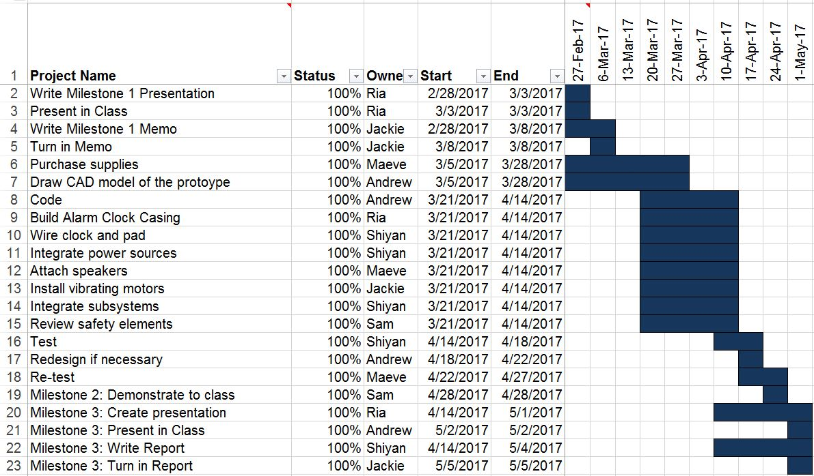

The Gantt chart in Figure 39 was used to lay out a schedule for the team project and keep the group on track. It was broken down by subsystem to show individual responsibility for the duration of the semester. The Gantt chart was especially helpful for presentation and memo deadlines. While it was helpful to create a clear schedule, delays in subsystems made certain deadlines impossible to meet on time. Testing was shortened due to the fact that more time was needed to finish some subsystems. While abiding by the schedule was helpful, meeting class deadlines on time was more important.

# Appendix D: Expense Report

Figure 40: Project Expenses

|  |  |  |  |  |
| --- | --- | --- | --- | --- |
| Item | Quantity | Unit Price | Subtotal | Shipping |
| Arduino Uno | 1 | 23.99 | 23.99 | 0.00 |
| Vibration Motors | 5 | 7.95 | 39.75 | 5.72 |
| Speakers | 4 | Various | 11.59 | 0.00 |
| Wood | 2 | 5.50 | 11.00 | 0.00 |
| Ironing Pad | 1 | 16.99 | 16.99 | 0.00 |
| Misc Electronic Parts | 12 | Various | 23.11 | 0.00 |
| Misc Hardware | 2 | Various | 10.48 | 0.00 |
| Total |  |  | 142.63 | |

The project could have been improved if we reallocated some of the money spent on making the containment pad for the vibrating motors and the speakers into the budget for the electronic parts. This could have been used to purchase items, such as larger buttons or better wire, that would make the operation of the clock run more smoothly.

# Appendix E: Final Code

#include <LiquidCrystal.h>

LiquidCrystal lcd(7, 6, 18, 12, 3, 2);

int starttime;

int activetime;

int prevoustime = 0;

int hours = 0;

int mins = 0;

int ahours = 0;

int amins = 0;

bool shutoff_alarm = false;

void setup()

{ lcd.begin(16, 2);

lcd.clear();

Serial.begin(9600);

pinMode(18, OUTPUT);

digitalWrite(18, HIGH);

pinMode(13, INPUT);

digitalWrite(13, HIGH);

pinMode(11, INPUT);

digitalWrite(11, HIGH);

pinMode(10, INPUT);

digitalWrite(10, HIGH);

pinMode(8, INPUT);

digitalWrite(8, HIGH);

pinMode(A0, OUTPUT);

digitalWrite(A0, HIGH);

pinMode(9, OUTPUT);

pinMode(12, OUTPUT);

starttime = millis()/1000;}

void loop()

{ while(digitalRead(8) == LOW)

{ lcd.setCursor(6,1);

lcd.print("Alarm");

lcd.setCursor(6,0);

if(digitalRead(11) == LOW)

{amins++; }

else if (digitalRead(10) == LOW)

{ ahours++;}

lcd.setCursor(6,0);

if(ahours < 10)

{ lcd.print("0");

lcd.print(ahours); }

else

{ lcd.print(ahours);}

lcd.print(":");

if (amins < 10)

{ lcd.print("0");

lcd.print(amins); }

else

{ lcd.print(amins); }

if(amins > 59)

{ ahours++;

amins = 0; }

if(ahours > 23)

{ ahours = 0; }

delay(500);

lcd.clear(); }

if(digitalRead(13) == LOW)

{ lcd.setCursor(5,1);

lcd.print("Set Time");

lcd.setCursor(6,0);

if(digitalRead(11) == LOW)

{ mins++; }

else if (digitalRead(10) == LOW)

{ hours++; } }

activetime = (millis() / 1000) - starttime;

if(prevoustime < (activetime - 59))

{ mins++;

prevoustime = activetime; }

if(mins > 59)

{ hours++;

mins = 0; }

if(hours > 23)

{ hours = 0; }

lcd.setCursor(6,0);

if(hours < 10)

{ lcd.print("0");

lcd.print(hours) }

else

{ lcd.print(hours); }

lcd.print(":");

if (mins < 10)

{ lcd.print("0");

lcd.print(mins); }

else

{ lcd.print(mins); }

if(ahours == hours && amins == mins && !shutoff_alarm)

{ //motor

tone(9, 1000,30000);

delay(30000);

noTone(9);

tone(5, 1000, 30000);

delay(30000);

noTone(5);}

else

{ delay(200);}

lcd.clear();

/*

Serial.println(mins);

Serial.println(hours);

Serial.println("");

Serial.println(amins);

Serial.println(ahours);

Serial.println("");

Serial.println(activetime);

Serial.println(prevoustime);

Serial.println(starttime);

Serial.println("");*/}

# Appendix F: Team Members and Their Contributions

## Team Member 1: Andrew Travis

Originally, my subsystem was the alarm clock casing. After collaborating as a team on the clock module subsystem, it seemed that I had the best grasp on the system needed we needed to operate the clock, so I switched subsystems. After switching subsystems, I did research on the most efficient way to wire an Arduino in order to make an alarm clock. After testing a couple of different set ups, I found only one that worked. Once a working clock was developed, I edited a base code that I found online, as mentioned in the clock module subsystem portion of the memo. To make the code work the way we needed it, I added lines to the code that added in both a secondary alarm that was to go off a set time after the original vibration went off, and to add a function that shut off the alarm once the user was up and moving. I also helped with the assembly of the whole system and making sure that all of the power sources were able to fit inside the casing without disturbing the wiring.

## Team Member 2: Jacqueline Floyd

I began by researching into my subsystem, the vibrating component. I found that the best way to make something vibrate was a vibrating motor. I looked into the available motors for sale in our price range and chose the motor that was the best fit. Once they came in, I tested them by hooking them up to a power supply to make sure they worked, and tested different things to mount them on. We eventually decided against mounting them on something because it would likely absorb too much vibration. I soldered the motors together in parallel, and then redid them in series once we determined that would work better. I also soldered the speakers and motors to the wires that would connect to the breadboard in the clock. I tried to help troubleshoot problems we had with the code, but ultimately it was Andrew that solved the problem and got it working. I sewed the pad that the motors and speakers go into, and drilled holes for the power cord, speaker and motor wire, and buttons in the casing. I also countersunk the holes for the buttons because the wood was too thick for them to reach the top. I was also present and helped with testing and assembly of the product.

## Team Member 3: Maeve Tucker

I was responsible for the speaker subsystem. Most of my effort went into the initial research. I am not particularly knowledgeable when it comes to electronics, so I spent a lot of time exploring different types of speakers and how they work. I found the indicator piezoelectric buzzers would be the best for our application and found where to order them. The speakers themselves are around $4-$6, but with shipping and handling, it was tough to find a set of speakers that would fit our budget. I initially tested the speakers by simply connecting them to a AAA battery and seeing if they made noise. Once we decided the first set of speakers wouldn’t work, I went through again to find a reasonable speaker with a fair price. Since I chose piezoelectric buzzers, I became responsible for developing a physical way to control alarm volume since the buzzers have a set minimum volume. I created the speaker housing to address this concern and to secure the placement of the speakers in the pad. I also found and used the computer app to test the volume and frequency of the buzzers at various stages of prototyping. Throughout the project, I maintained a calendar with important meeting dates, topics, and deadlines. I also collected our notes from early in concept development, typed them, and uploaded them to a shared folder so that the entire group could review and reference them.

## Team Member 4: Samuel Pollinger

For the first part of the project, the majority of my work was material selection due to the safety standards that needed to be met. I consulted with my mother, a home and careers teacher, and my father, a high voltage electrician, for what materials would be the safest and most cost effective for the project. I was able to obtain electrical tape, 120 volt wire casing, and wire crimps from home, that all met normal safety standards. With my mother’s help, I picked out the ironing pad as the material to be used as the pad. During the construction of the project in the shop, I assisted with any miscellaneous tasks, like helping Jackie with drilling and soldering, since most of my safety reviews would have to happen after certain sections were fully completed. Near the end of the project, I crimped wires and insulated bare wire and solder points with electrical tape. I set up the wire casing that went between the clock casing and pad and made sure all possible points of fire hazards were insulated. Finally, I monitored the temperature of the pad and casing during testing and the class demonstration. I also maintained the Gantt Chart throughout the course of the project.

## Team Member 5: Shiyan Yang

My subsystem in this project was power supply, which essentially is designing and building the circuit around the clock module. My part in this project started by looking for a power cord for the Arduino board. Then I moved onto designing the circuit for the vibration and speaker system. I happened to be taking Electronic Instrumentation this year, and what I learned in that class helped me in my subsystem tremendously. With what I learned, I tested the speaker and vibration systems to find out their electronic property and built a circuit with an electronic switch that was controlled by a signal sent from the controller. I also designed the circuits, constantly with Ohm’s Law in mind, preventing any current overload or unnecessary voltage drop. After the vibration motors and speakers were put into the padding and wrapped in a Hollowed Out 120 Volt, I finished up the circuits for the clock.

## Team Member 6: Ria Shroff

I initially was going to help with the electrical components, however, my teammates proved to be extremely skilled and interested in this subsystem-whereas I had a lot that I would have needed to learn or need their help for-so after wiring a very preliminary circuit to just get an idea of what we would be building, I ended up trading with Andrew and Shiyan. I then moved on to creating the casing. After going through the considerations outline in the section on casing in the memo, I ended up drawing it in illustrator. Next, went to the laser cutter downstairs in the processes shop and ended up having John go through it, fix some minor errors and cutting it into a piece of thin, 1/16th inch plastic as a test. Next, we cut it into the 1/4th inch wood. However, the sketch had been made originally for a 1/8th inch depth piece of wood. This meant that the box didn’t quite come together at the joints. It was stable but could be made stronger. We considered gluing and rounding the edges down to also make the edge pattern go away. Instead, I redrew the Adobe Illustrator file and taking it down to the Tech Valley Center of Gravity Makerspace downtown to cut. There I found out the cut bed was slanted as it took one side three passes more than the other to come out of any given piece. This ended up being the final box design. Lastly, I cut the words onto a piece of cardstock to give a professional aesthetic to the words.

# Appendix G: Statement of Work

The second project of the semester in IED has very broad instructions. Groups were instructed to design and build anything of their choosing with the only true constraint being that it be complex enough that each team member have one major subsystem to work on or be in charge of. This team also added some additional constraints preemptively, before even brainstorming any potential problem spaces. For example, the project chosen would be reasonably within skills the whole group already possessed (meaning programming something completely from scratch or that being the most intense part of the project was prohibited). Additionally, this group agreed that every deadline would be prepped for by completing work at a minimum of two days in advance. These constraints helped determine what kind of project we would actually make. We initially brainstormed many different problem spaces and some potential solutions. However, each problem space was carefully considered and ranked for: feasibility to develop, demand, ability of group to make it, and value of problem space. Finally, we settled on the project that has been discussed throughout this paper. The skills demanded by this alarm clock project included knowledge of: CAD/Creative Cloud software, laser cutter operation, wiring and testing of electronics as well as theoretical concepts of circuit diagrams, current and optimized circuitry, programming (that Andrew stepped up and learned), understanding properties of various materials, sewing, and product assessment for pieces integrated into the system. Initially, the programming was intended to be outsourced as it appeared too complicated for a group that had never coded before. Other than this, every other subsystem to the alarm clock seemed understandable enough to complete. Additionally, a Gantt chart was created to make a timeline for accomplishing tasks within making the clock. Lastly, we also created a budget to ensure that excessive costs did not surprise us later in the project to keep the budget in scope as well.

# Appendix H: Professional Development - Lessons Learned

This team had a lot of passionate members who came into the project with goals. These goals initially didn’t necessarily line up. The first few meetings were tricky because of the work needed to align a set of group-wide objectives. In class we were taught of Tuckman’s Team and Group Development Model, which can be seen in Figure 41, in which the performance and effectiveness of a team evolves as they understand one another better. Our storming period was particularly intense. However, it actually was to the benefit of the team because while it was intense, it was short and quickly made us get to know one another. In our case, as it didn’t kill our group, it made us stronger.

Figure 41: Tuckman’s Team and Group Development Model

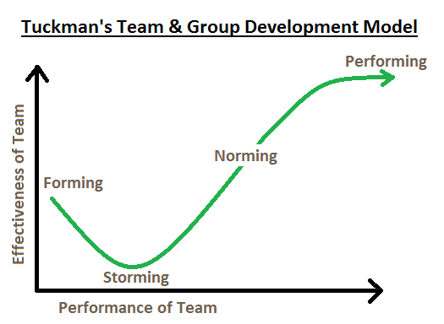

We quickly moved into the performing phase and worked as a cohesive unit. When something needed to be done, whoever was knowledgeable on the task would step in to teach or do and explain the task to the rest of us. This team was incredibly organized because of efforts by Jackie, Sam, and Maeve which ensured objectives were completed on time and tested.

The tasks we had to go through can be divided into problem definition and solution concept generation, prototyping, planning, presenting, and writing. In each of these categories there are things that worked well from the start and things that we learnt from over the course of the project.

One of the most important things we worked through as a team is something we realized would happen again and again in team projects: needing to understand what goals we shared and which ones needed to be compromised on. There were important priorities of usefulness of project, difficulty of project, team ability to perform skills needed, and excitement over given projects. Each of these goals were important but ranked differently for team members. Instead of immediately going into brainstorming, establishing what group members want out of a project at the start may help in the future to reduce confusion and dissonance in the early steps of a project.

Brainstorming problem spaces proved to be very successful because this team worked together and was able to play off one another to rapidly create a multitude of very interesting problems. This made it easier when coming up with solutions to have a lot of things to think about.

Our solution generation phase also worked very well as the team made sure to not fixate on the first possible way to change the existing solution of alarm clocks, but instead went through a comprehensive research phase to see what products already existed. We also evaluated different solution concepts both quantitatively and qualitatively through customer surveys and careful evaluations of the safety and effectiveness of each solution.

One thing we couldn’t plan for was the complexity of actually wiring and programming an alarm clock with the components we added. Shiyan and Andrew took charge quickly and impressively adapted to the challenge at hand. In future projects, they now have that experience to go off of and won’t be surprised at the start.

During prototyping, we came across the typical challenges of materials behaving slightly differently than expected or desired. However, the team was able to adapt and work on the spot. This also happened less than it usually does because the team conducted comprehensive evaluations of the material choices made before ordering and buying parts.

Presentations are one place where we made a dramatic improvement between the first time we worked together and the second. The first time, the presentation was completed too late and did not afford time for the team to practice together. Also, as a team, we had a few different styles of presenting and strengths and weaknesses. However, we took the feedback from the first presentation and were able to incorporate it quite successfully into the second presentation. In summary, hands were removed from pockets, a single person changed slides for the team, speaking speeds were more thoughtfully modulated, we waited and did not speak over one another, we felt calm and prepared, we rehearsed our slides, and we listened to audience members. Future improvements that will come from becoming more comfortable with presentations in general include reducing filler words and pauses and visually appearing more comfortable in front of a group.

The planning process did not go as smoothly as we could have hoped because of the hectic nature of everyone’s schedules this semester and the heavily procrastinating nature of some teammates. However, this slowly and slightly improved over the course of the semester and will only improve through future group projects. Additionally, external challenges present this semester were temporary and may not be problematic in the future.

Lastly, this team worked together very well when it came to writing. Each of us are experienced in writing from prior work, and it was very easy to divide sections and expect quality from section to section would not vary dramatically. This made it easy to proofread the paper and just add a few words here and there to better explain concepts without having to worry about having to rewrite complete sections so that others could understand them.

The one thing that did not go according to plan is that early on we wanted to incorporate white noise into our project as an auditory aid to help the user fall asleep. However, the selected speakers were not able to have noise play out of them and instead stayed certain pitches/volumes regardless of other manipulations. If we were to iterate further, we would perform an even more comprehensive analysis of speakers before purchase and work to manipulate the code to accomplish our goal.

# Appendix I: User Manual

Nocturnal Knock Turtle Alarm Clock

**User Manual**







**CAUTION** Do not leave system in alarm mode for an excess of 20 minutes or system may fry. Do not attempt to rewire or correct electrical malfunctions; please report them to the manufacturer. Do not get alarm clock wet. If you notice excessive heat coming from any part ofthe device, promptly unplug the clock and report the malfunction. Spot clean and air dry the alarm pad if necessary.